**Mulesoft Learning__**



* Mulesoft is a vendor which provides tools like Anypoint Studio n Anypoint platform to design,develop,deploy,manage,secure,reuse the apis either on cloud or on-premise by following API led connectivity Approach.
* Mulesoft is a Middleware product which helps to sync 2 or more+ enterprise applications so that org can operate all apps together in smooth n sync way .

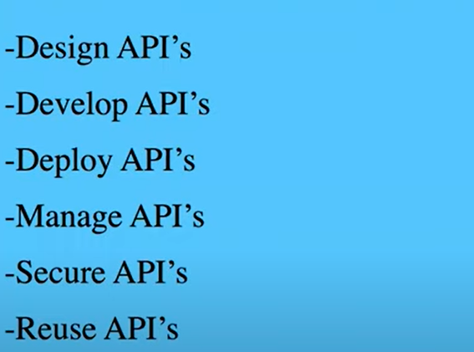

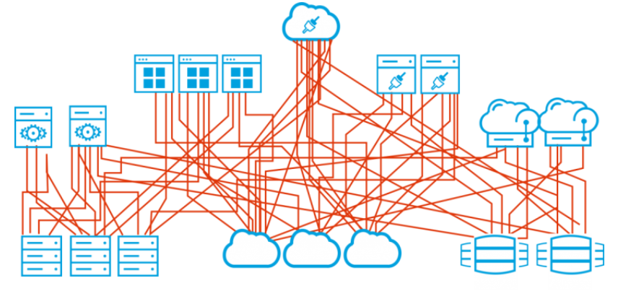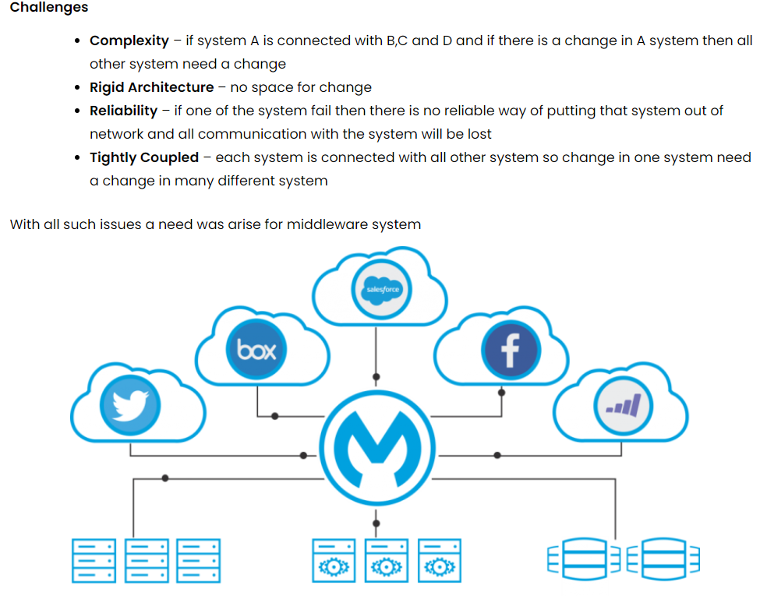

**MULESOFT API LIFECYCLE**

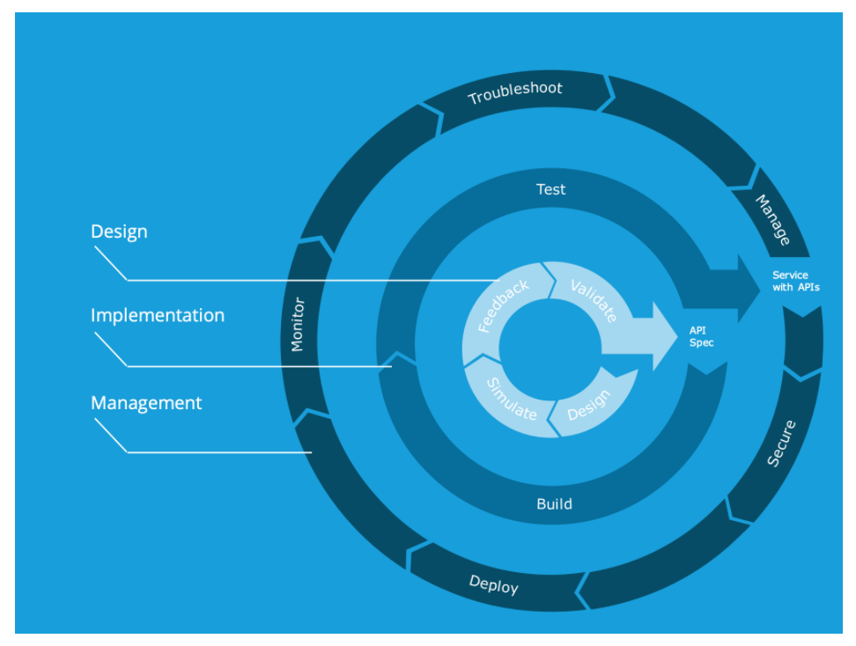

Design

* **Design:** Identify process and business requirements, create logical data model, translate into logical service, API groupings
* **Simulate:** Model API resources, model API operations/methods, model request/response payload/codes
* **Feedback:** Mock up the API, publish interactive console, create notebook use cases, receive developer feedback
* **Validate:** Modify API design as appropriate based on developer feedback, continue to validate

Implementation

The two steps that go into the implementation stage are building and testing.

Management

Within this lifecycle stage are the following steps:

* Secure
* Deploy
* Monitor
* Troubleshoot
* Manage

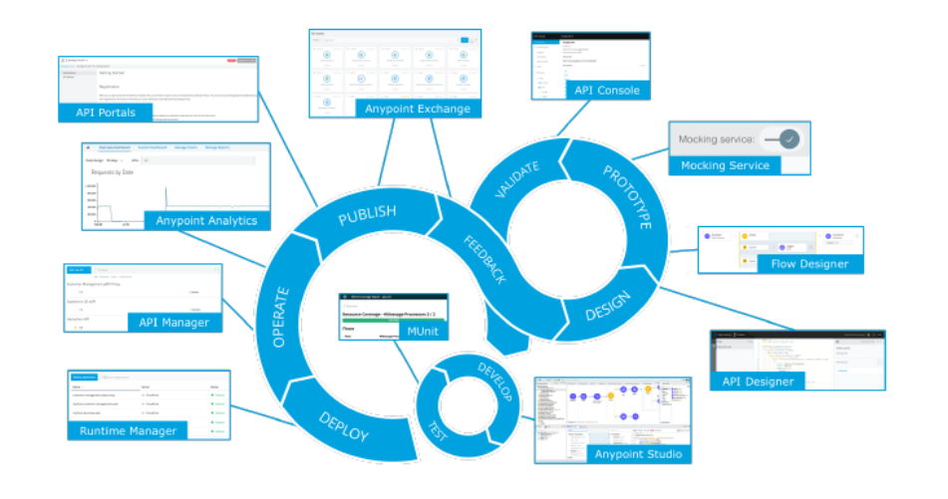

# ****MULESOFT API LIFECYCLE – USE CASE****

As we already walked through the [MuleSoft API lifecycle theory](https://mulesy.com/2020/03/20/mulesoft-api-lifecycle/) so now it’s time to start with the actual MuleSoft API lifecycle – Use Case.

**Requirement –**Mobile team come with a requirement that they need an interface which can accept the order placed from the mobile application and can also provide the user’s order details in case they need at any time.

NFR (Non Functional Requirement) – Mobile team want to use basic authorization for calling the service and the response should be in 5 sec max.

MuleSoft team/consultant looks into the requirement and will start with the API specification. Here team needs to provide interface for order management. API will provide user’s order information and accept the user’s placed order.

**MuleSoft API lifecycle – Use Case**

**Design**

**API Designer** – We start with we create order-mgmt-api project in design center.

Click on create new and fill in the details

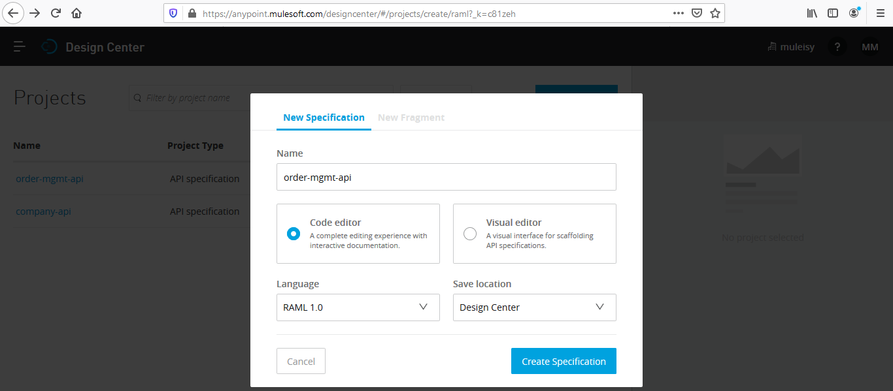

First we create the types.raml which will hold the type details which we are going to use in api RAML

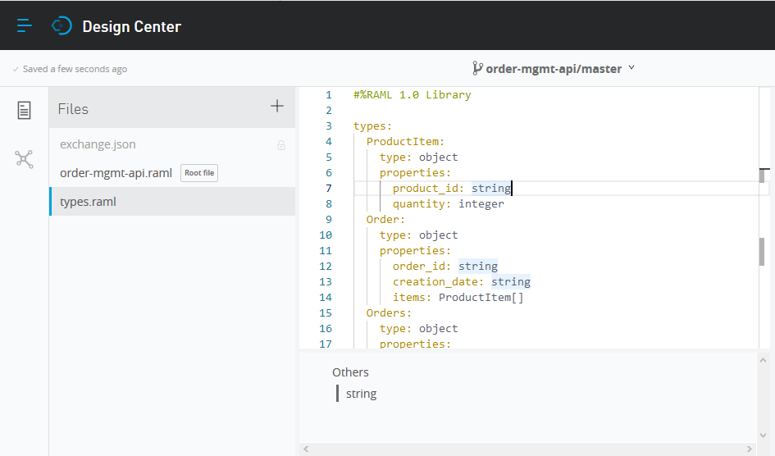

Second we create the api RAML which will hold the API specification

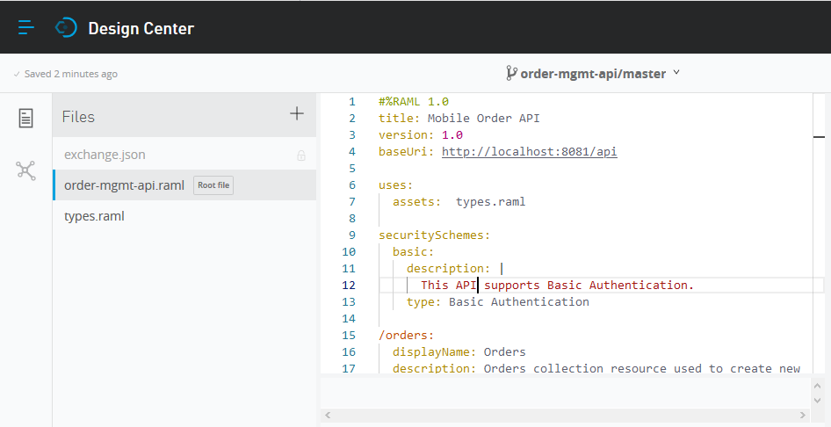

Specification will hold **order** resource which will have **GET** and **POST** method

**GET** will take the user id as query parameter and provide user order details

**POST** will take the user id and item details which need to create in order management system

Both methods will be secured through basic authentication

**Download the Sample** [order-mgmt-api](https://mulesy.com/wp-content/uploads/2020/03/order-mgmt-api.zip)

**Prototype**

**Mock Service –**Once we are done with the API specification then we enable the **Mocking Service** button

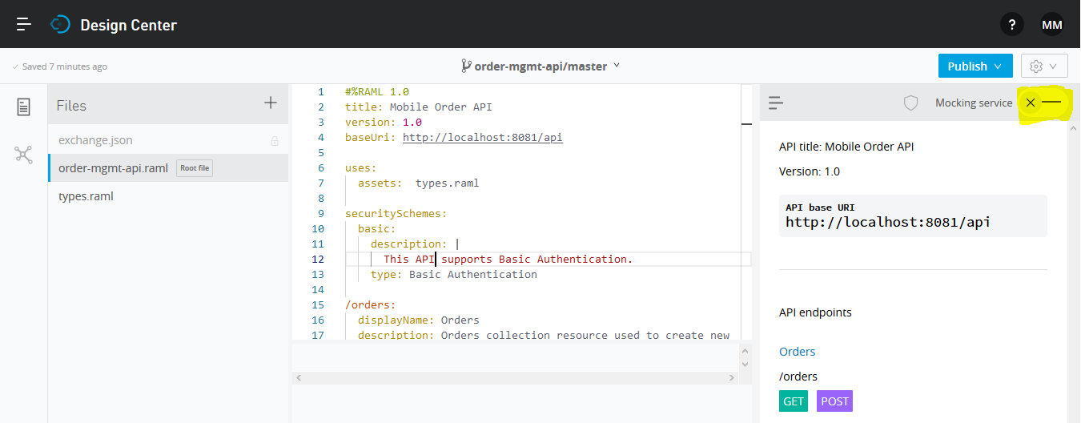

API base URI will be generated which can be tested through and API testing client like POSTMAN or SOAPUI

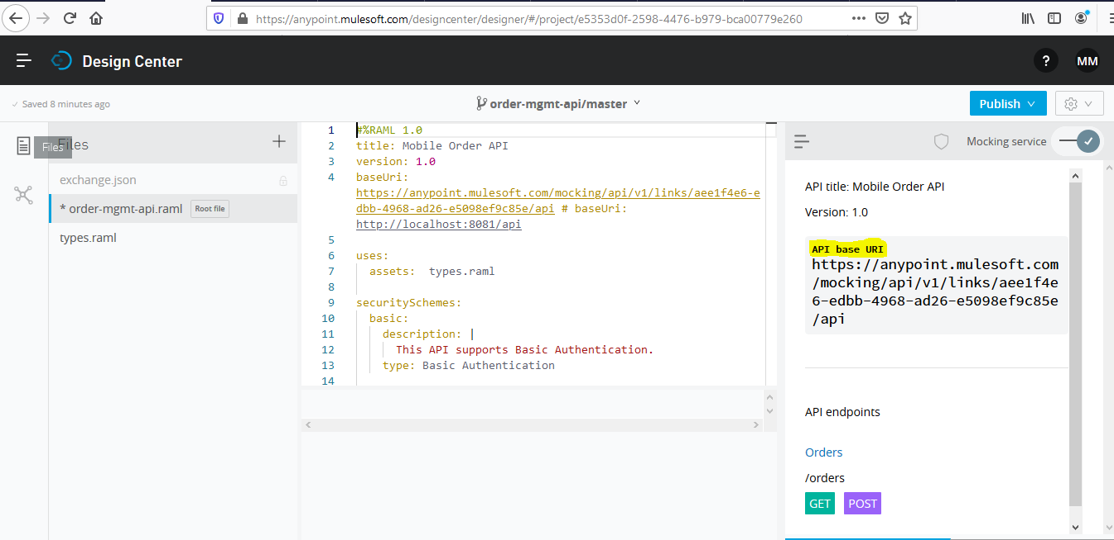

Select **GET**method and click on **try it**

Provide dummy userid and basic authorization details

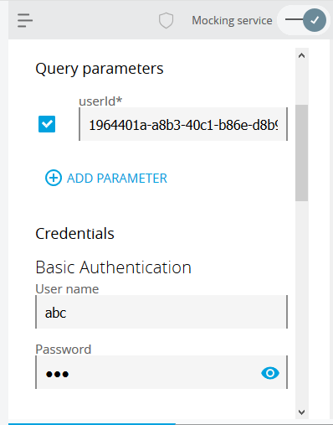

Then we can see the **200**response as well

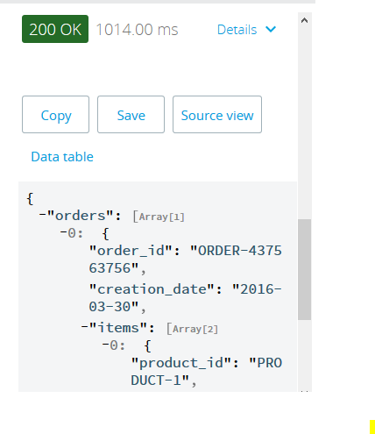

**Validate**

**API Console –**This console is generated by default by the API Kit router configuration. Once application is deployed to mule runtime then this console is available. Will show this when we generate source code for the application.

Till now is a recursive process where we keep on validating the RAML design/specifications with clients/vendors and based on the feedback either we again follow the process (RAML design -> Mocking Service -> Validate) or move ahead with development

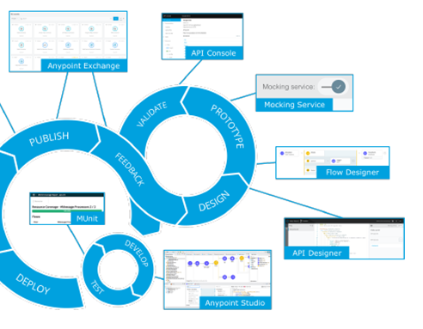

When we received the positive feedback from clients/vendor we move to Develop and Testing phase.

**Develop** –Anypoint Studio can directly download the API Specification (RAML) from design center and create a base mule application

Select File -> New -> Mule Project

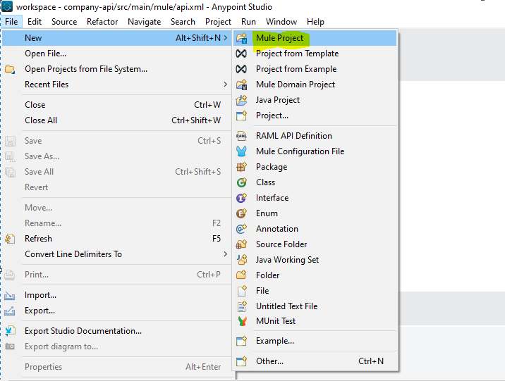

Select “From Design Center or Local files”

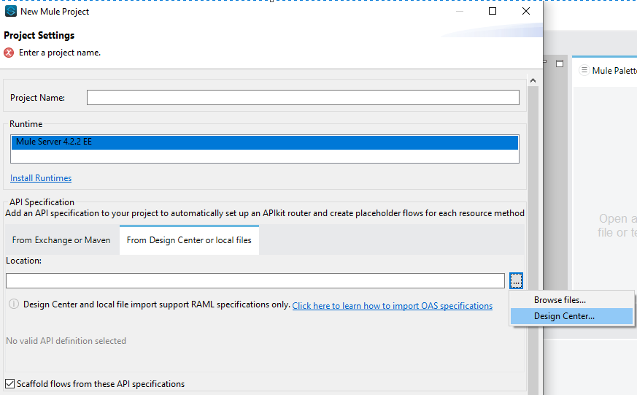

Select the order-mgmt-api from the selection box and click OK

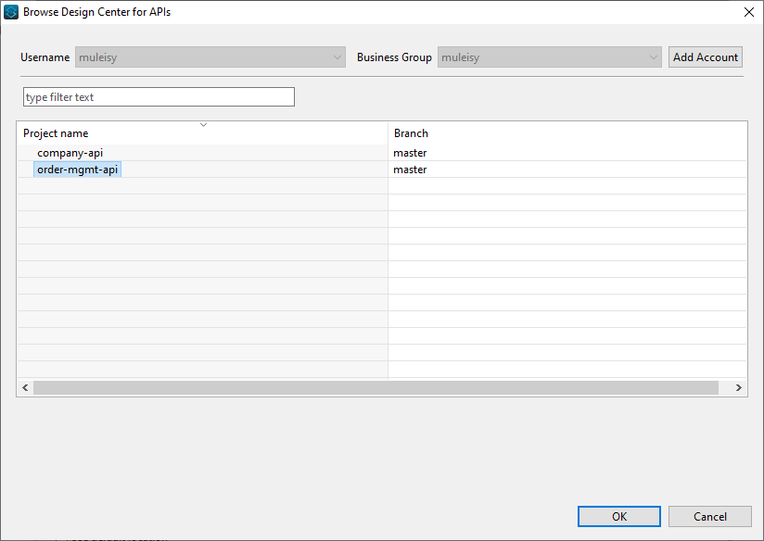

Provide the project name and click Finish

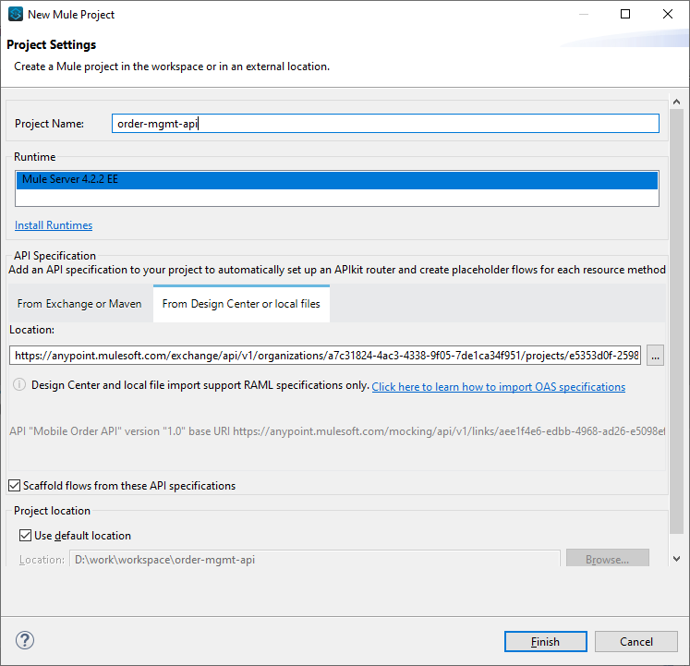

This will create a mule application with basic skeleton

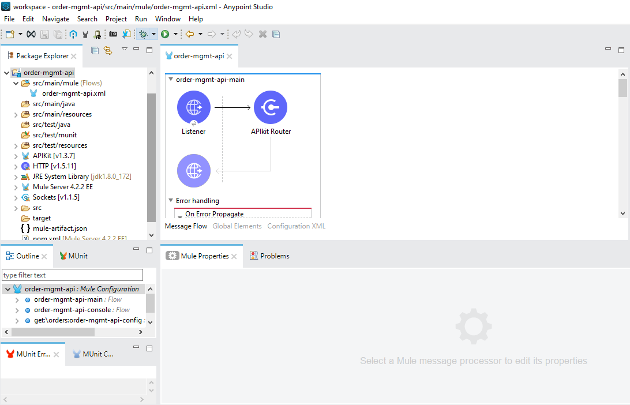

With both **GET** and **POST** method flows, based on the RAML specification

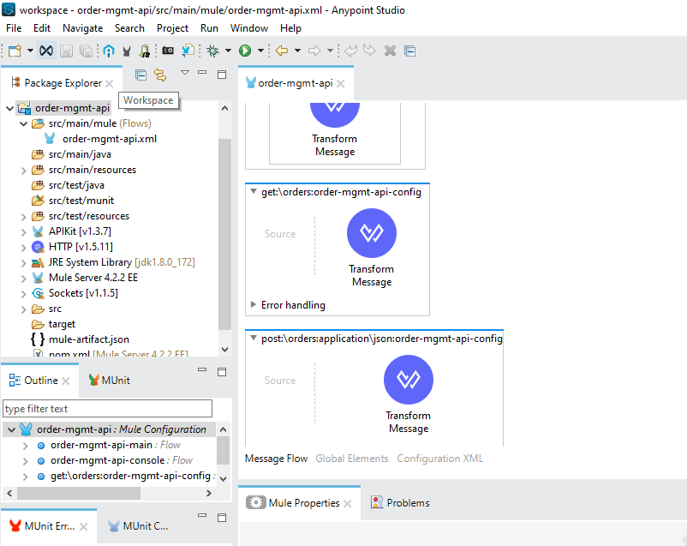

And API console code

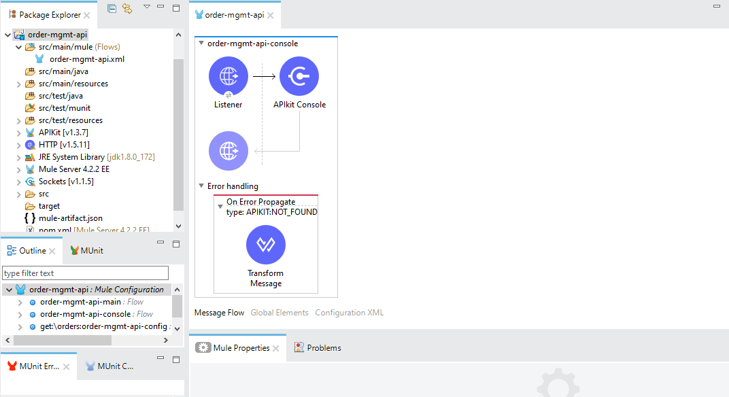

**Testing**– when we are done with the development and add the required logic in our mule application. We have to write the MUNIT to make it sure that future changes will not break the existing logics.

We can select the flow and create the MUNIT for the flow

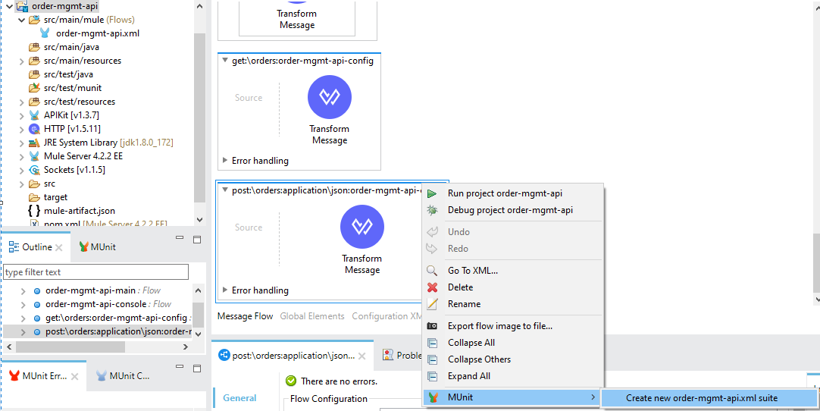

This will create the MUNIT for the flow which we can update as per our assertion logic

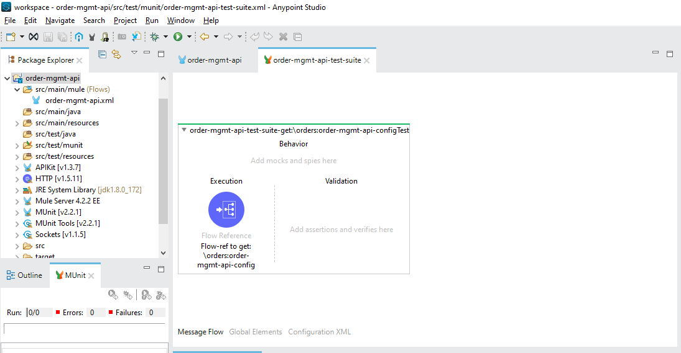

Download sample mule application project – [order-mgmt-api](https://mulesy.com/wp-content/uploads/2020/03/order-mgmt-api-1.zip)

**Deploy**

**Runtime Manager –**Once we are done with the development and MUNIT, then we can deploy our code to mule runtime. We will deploy our code to Cloudhub.

**Login**to**Anypoint Platform**and go to**Mule Runtime Manager**

First export the project jar which can be deployed to Cloudhub

Select the project -> export

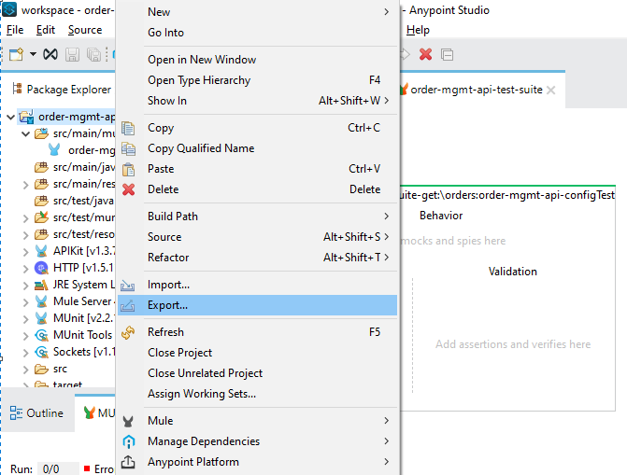

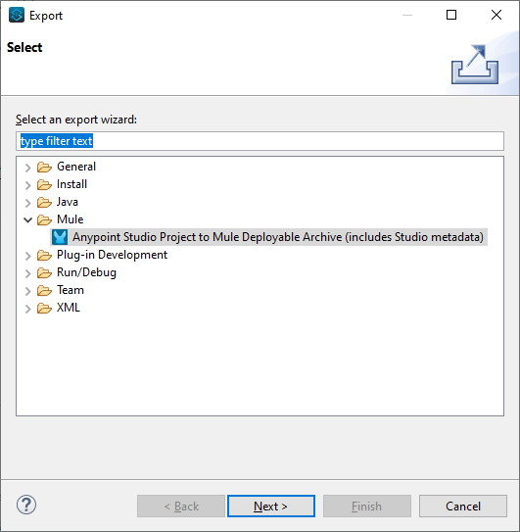

Click **Next**

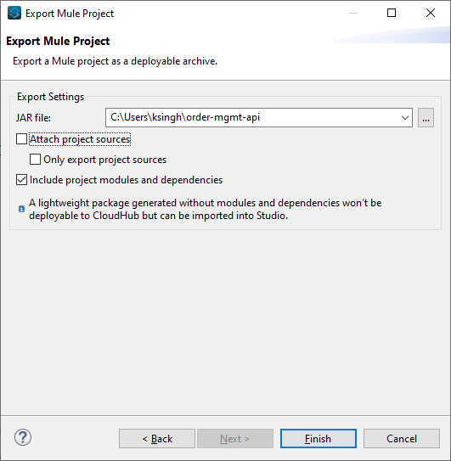

Please select “include project modules and dependencies” as we have to deploy the same project on Cloudhub

A **Jar** will be exported which can be deployed on Cloudhub

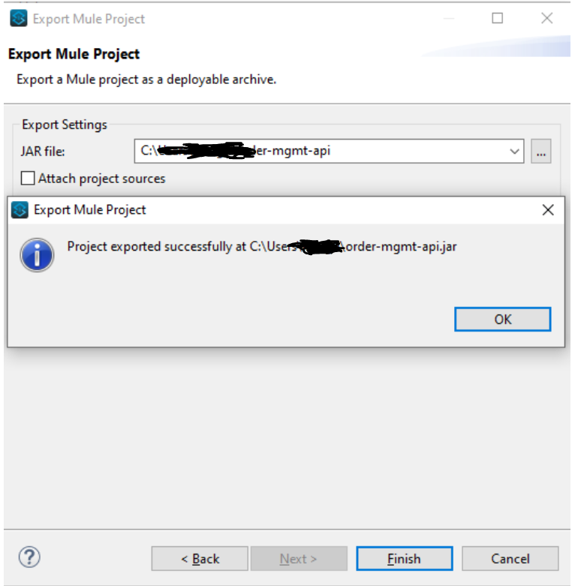

On Anypoint Platform – Select Runtime Manager

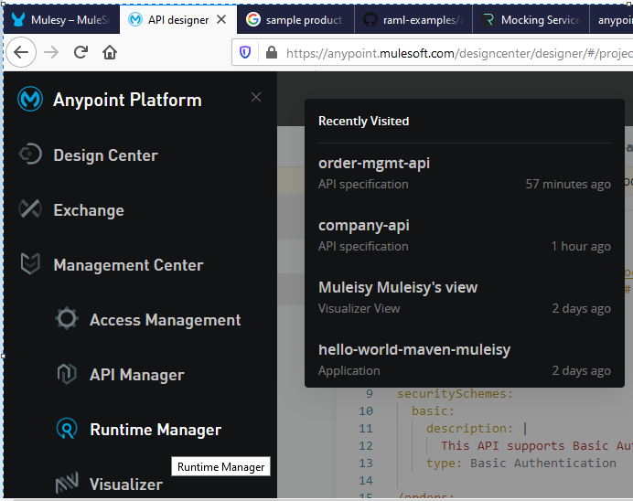

Click on Deploy application

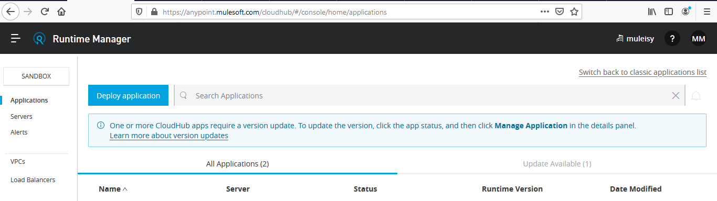

Provide the appropriate name and deploy the application

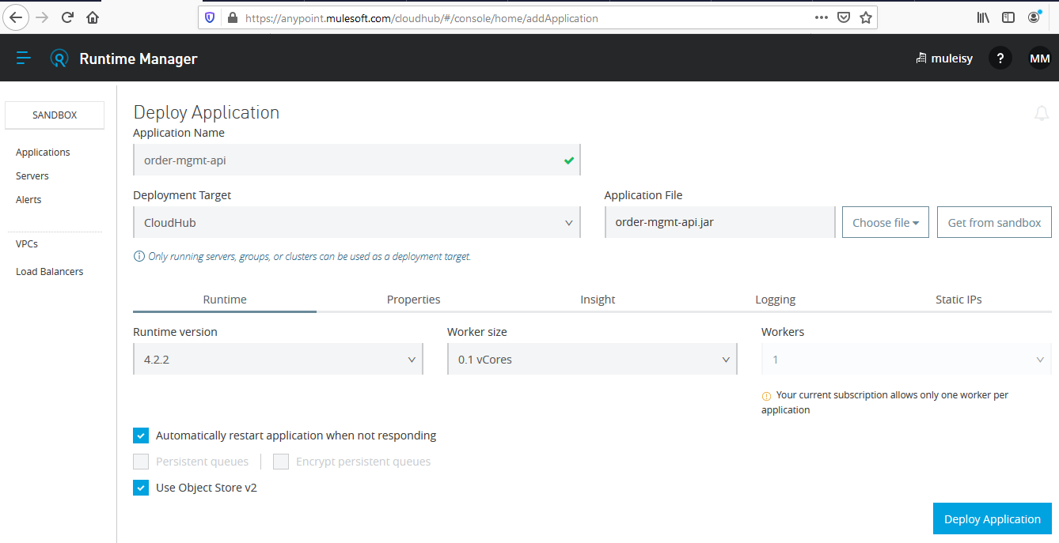

Once deployed we can test the API

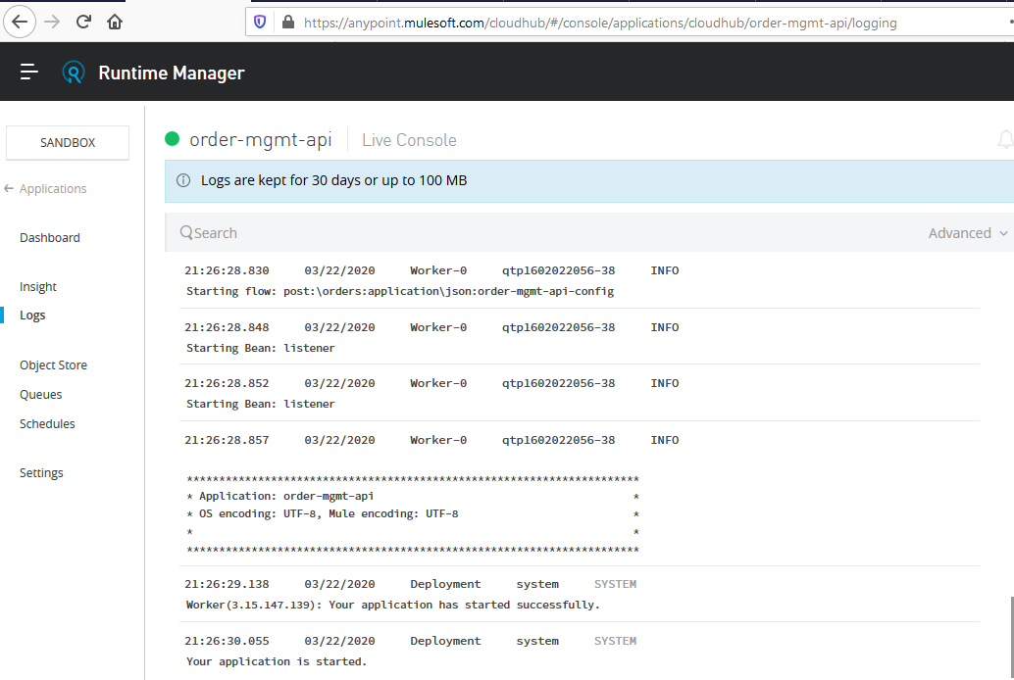

To test the API we need to create the URL which needs to be called

Click on dashboard

Select the domain name

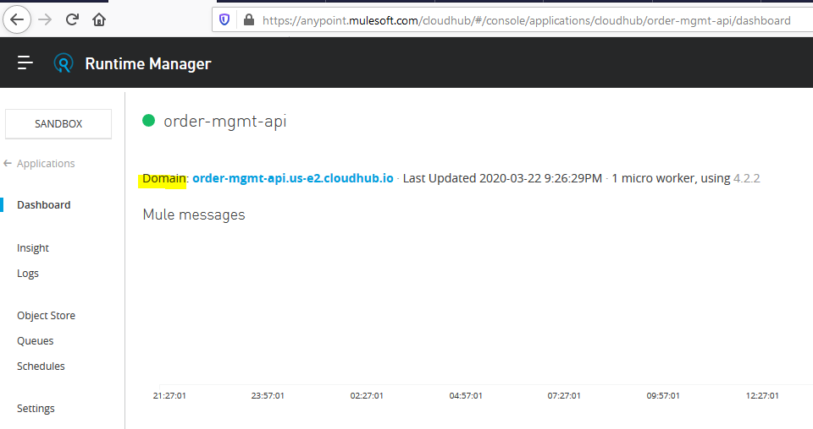

[http://order-mgmt-api.us-e2.cloudhub.io](http://order-mgmt-api.us-e2.cloudhub.io/)

HTTP will be as per the configured Listener in mule application – click on edit in Anypoint Studio

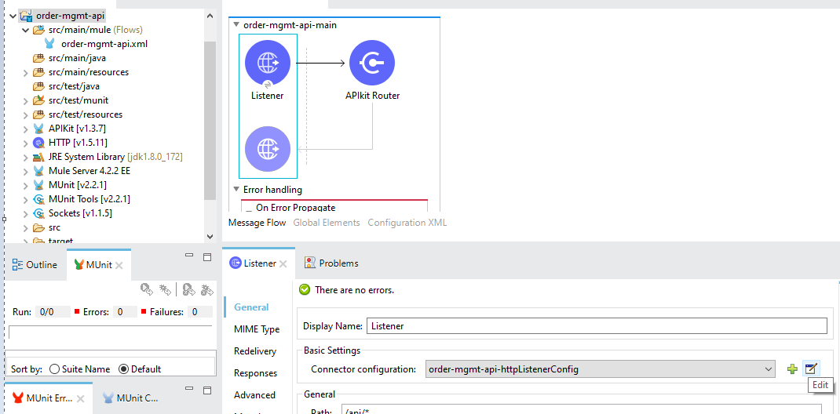

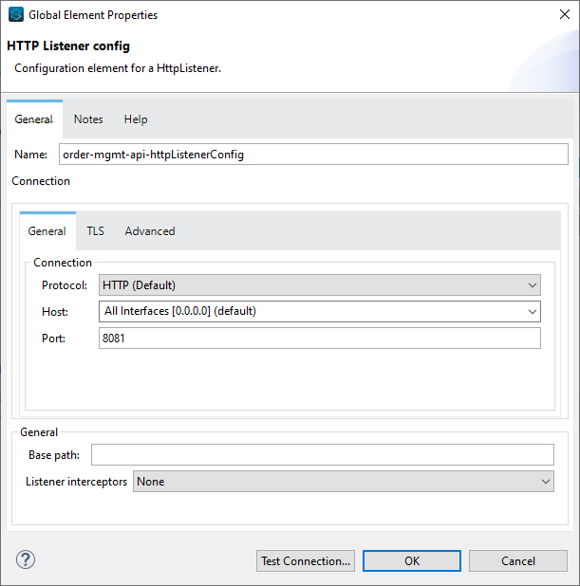

We can see here the default listener is HTTP

Remaining information we can get from path and RAML

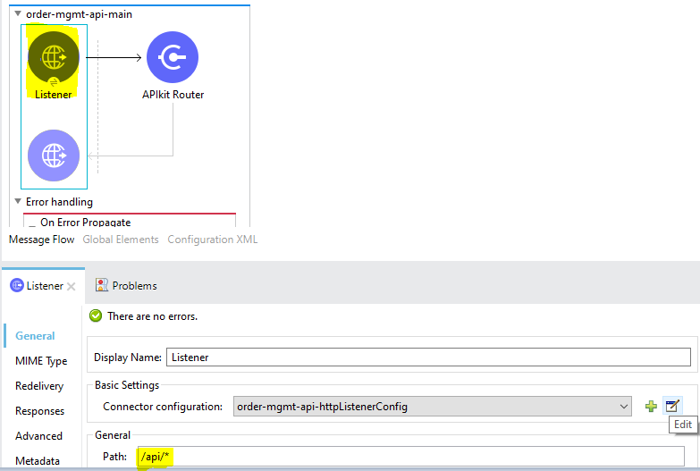

<http://order-mgmt-api.us-e2.cloudhub.io/api> + RAML resource

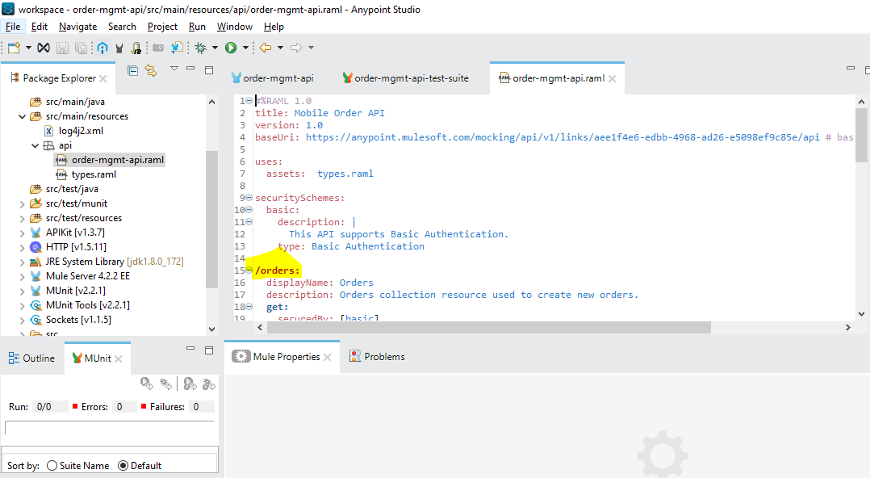

So effective URL is

<http://order-mgmt-api.us-e2.cloudhub.io/api/orders>

Add the query parameters

<http://order-mgmt-api.us-e2.cloudhub.io/api/orders?userId=1234>

When we test the API it will show the result

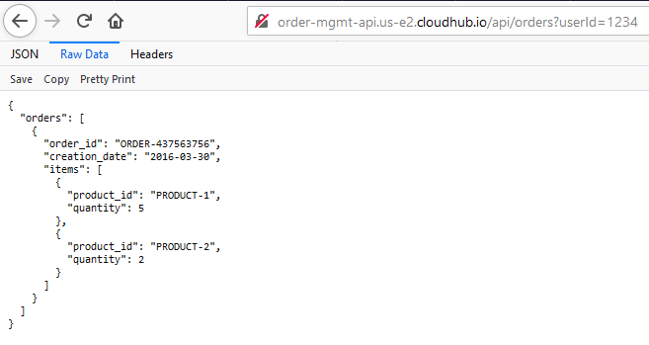

But we are still missing something, it still not secure as we are not providing basic authorization details. To add security, MuleSoft come with OOTB functionality called API Manager to easily secure the APIs.

**Operate**

**API Manager –**To apply policy in API Manager we have to add Auto Discovery details, please go through Auto Discovery tutorial to know the same.

Assuming now you know how to add Auto Discovery, we start the API Manager configuration by pushing the RAML from **Design Center** to **Exchange**

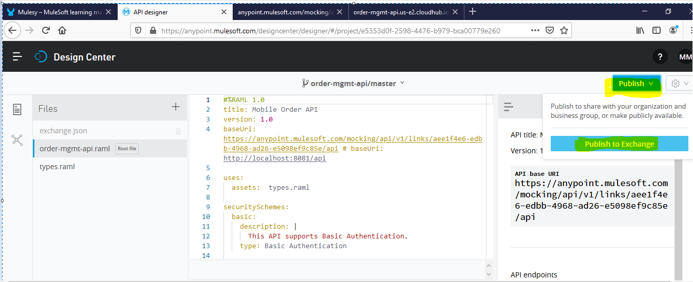

Click on Publish and then Publish to Exchange

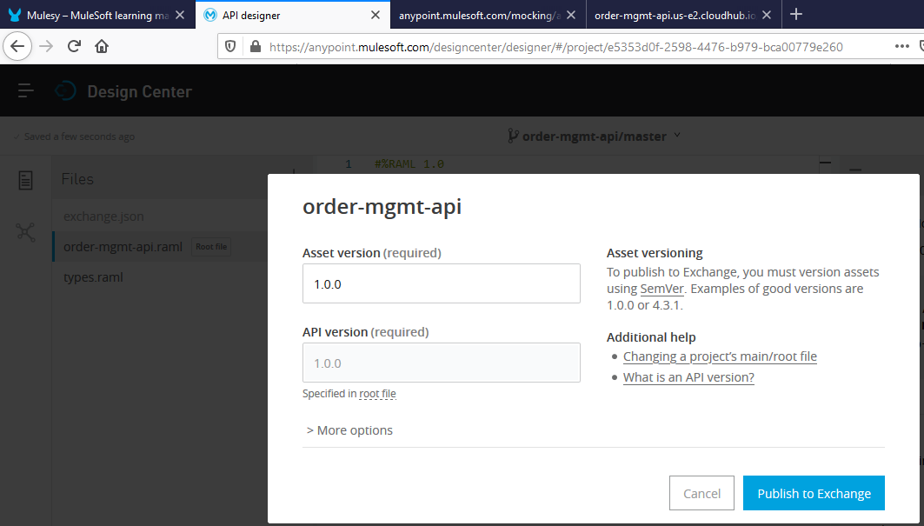

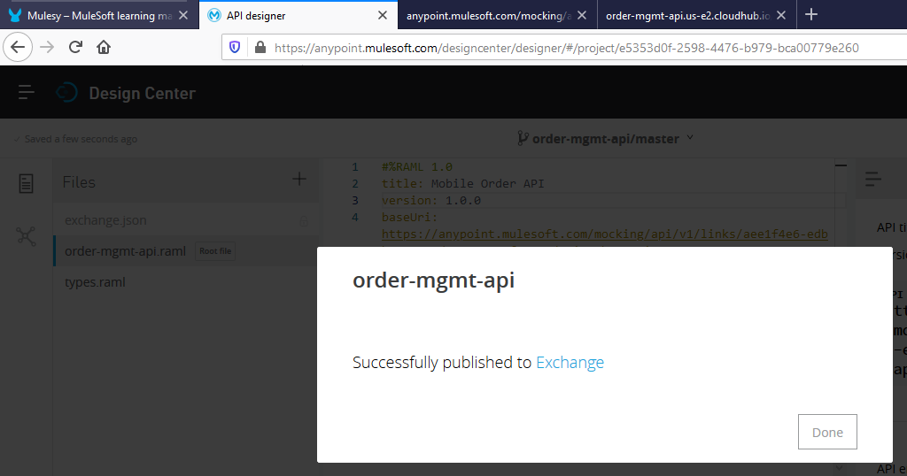

In **Exchange** now we can see the Asset

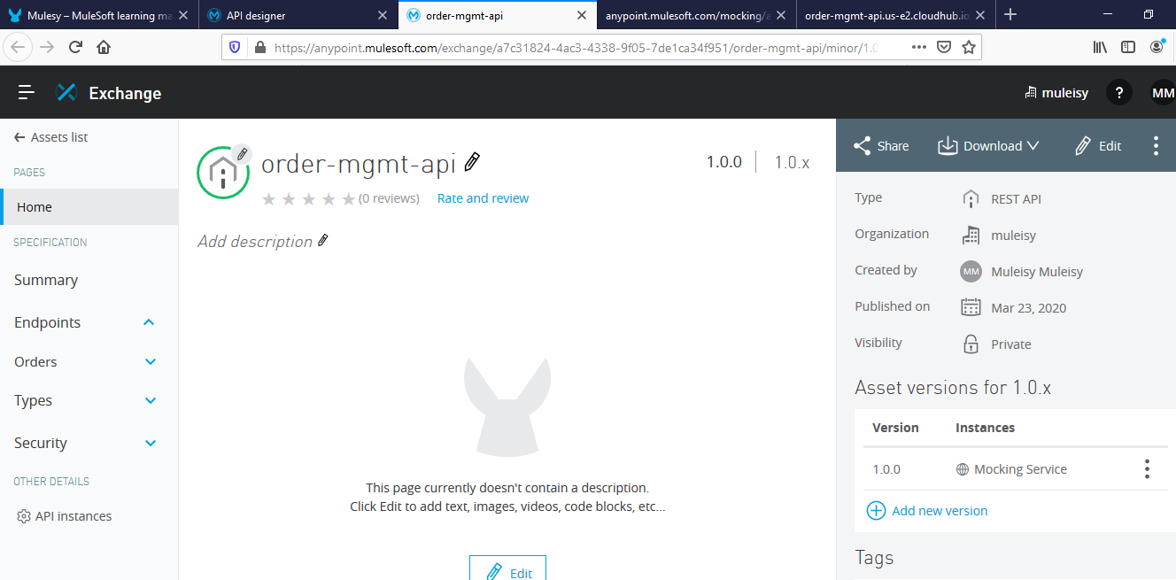

Now we move to API Manager and create the required configuration and add the Auto Discovery details

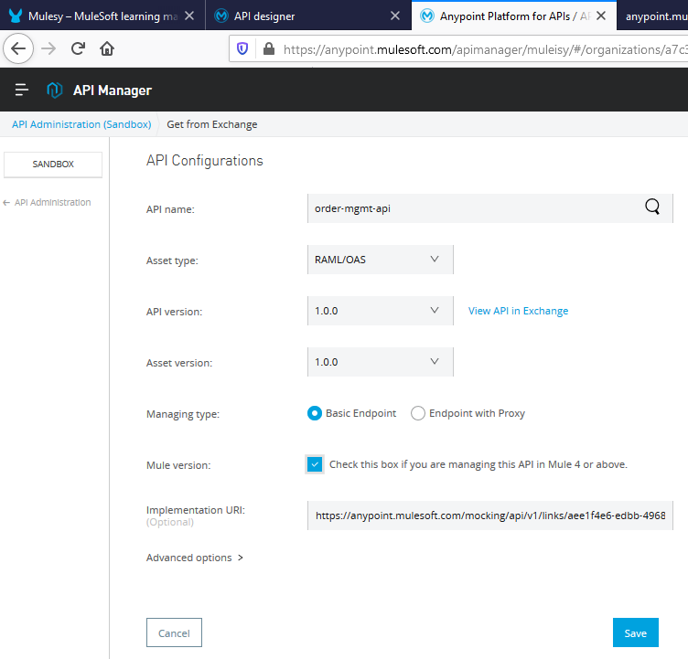

Once application deployed using Auto Discovery details, API Manager configuration will come in Active state from Unregistered state

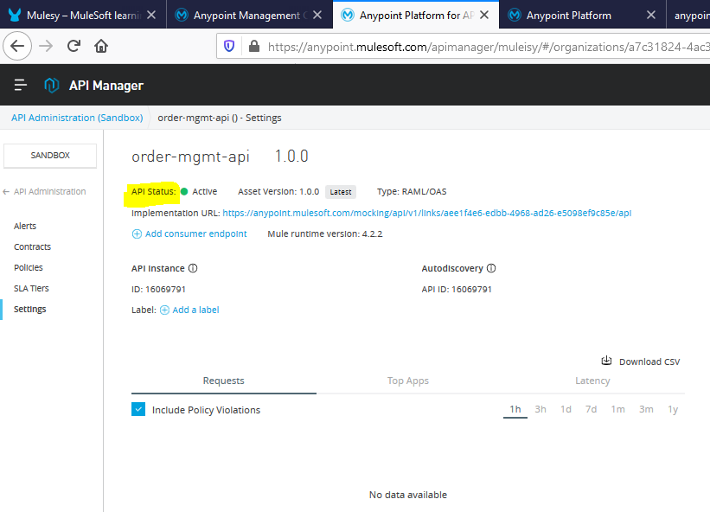

Add the Client id enforcement policy

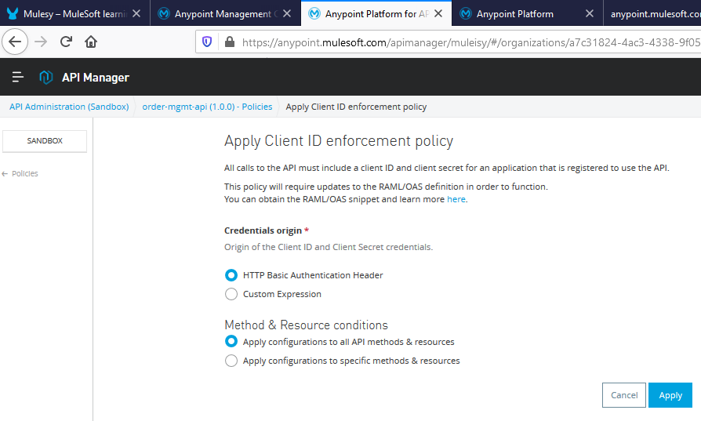

Now if we hit the same URL – we can see the API is asking for basic authorization

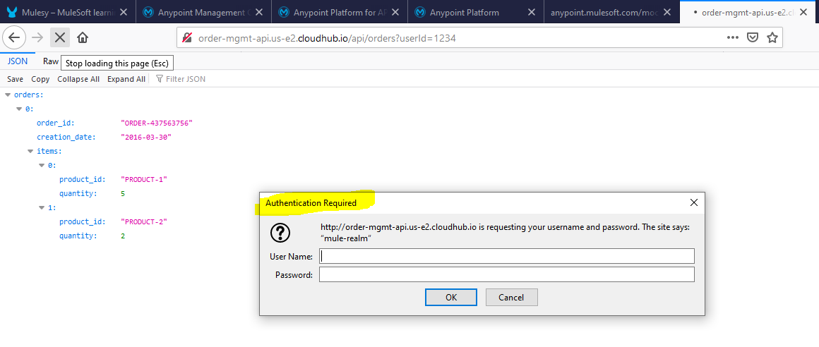

if not provided we will get below error

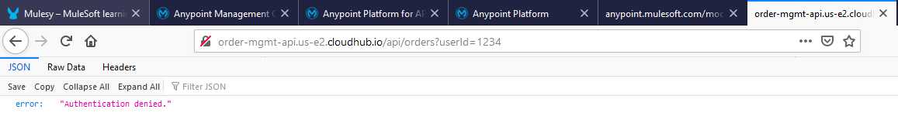

Will raise the client authentication request from Exchange

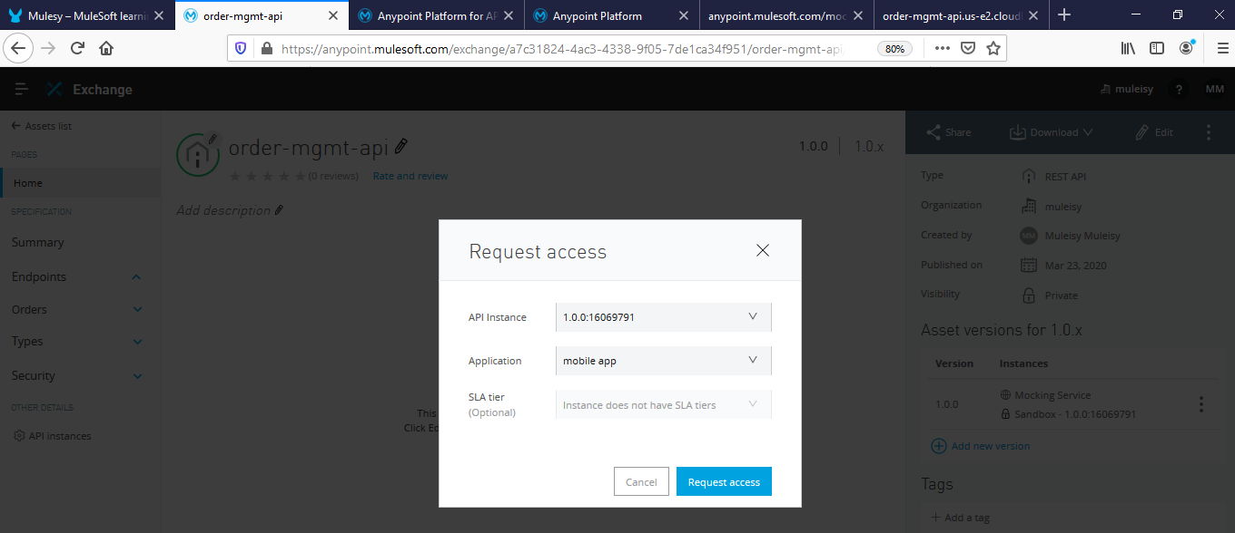

After providing the authorization details we can call the API successfully

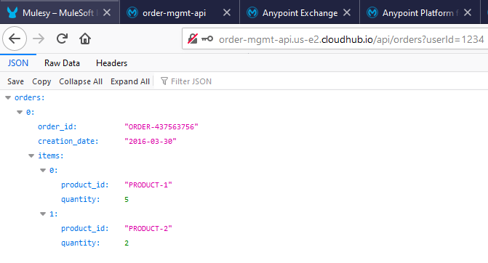

**Anypoint Analytics –**This is replaced with Anypoint Monitoring and Visualizer in current Anypoint Platform. For the Developer account we don’t have access to enable and show it here.

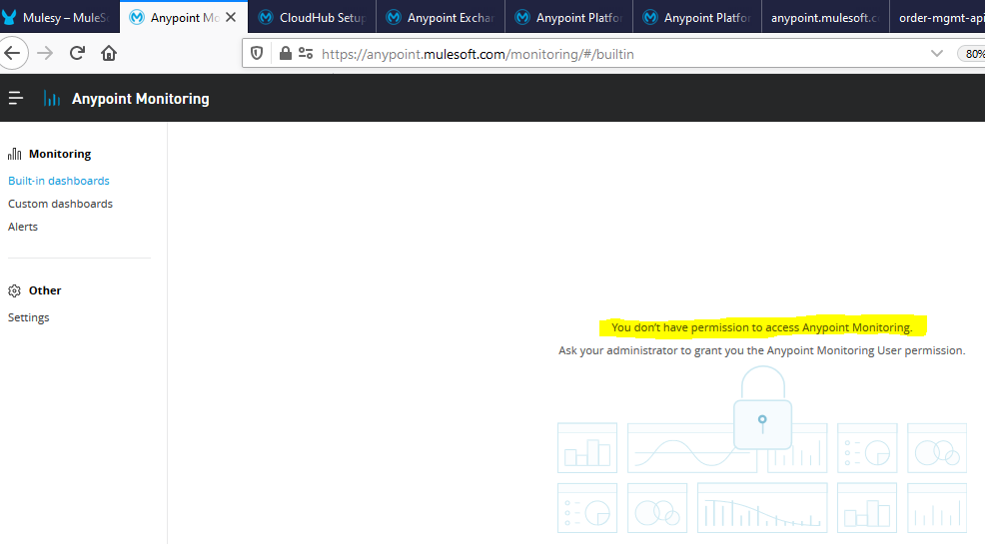

**Publish**

**API Exchange –**as a part of API Manager Configuration we add the Design Center project to Exchange. This will help the organization and connected partners to discover existing APIs as per their needs.

We also update the Exchange asset to include more meaning full information which can talk about the asset

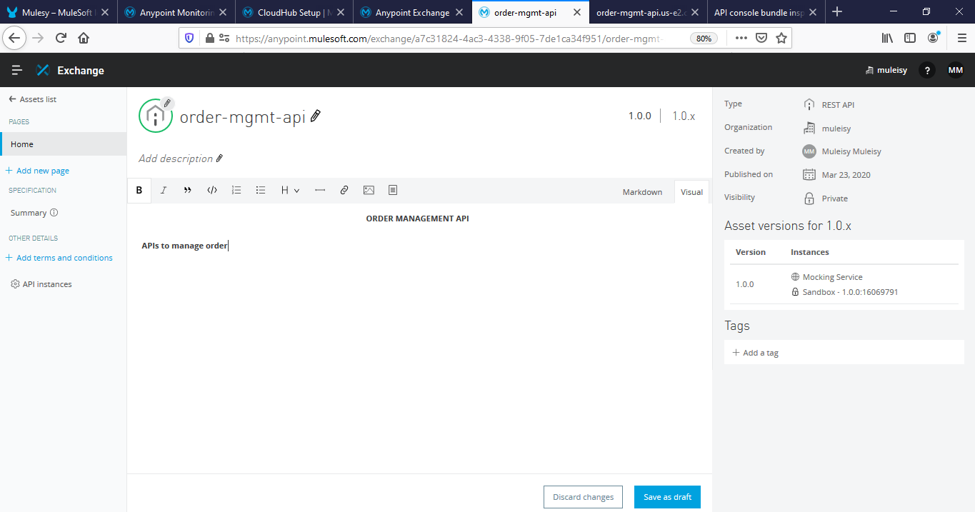

With this we end the API Lifecycle

**API Lifecycle will not stop here and again go into next lifecycle based on the feedback**.

E.g. Existing Order management APIs are not capable enough to handle customize items, so based on this new requirement a new set of API version e.g. 1.0.1 is created.

Anypoint Studio is used to build complex integration using various connectors.

Anypoint Platform is used to deploy n manage the developed APIs.

* SOA means creating web services that are easily discoverable n easily reusable but it had a problem with Scalability of ESB in case large no of services deployed on one single ESB.

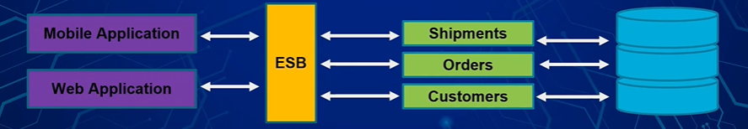

* Microservice means creating small independent web services that helps to overcome the problem of SOA by creating independent services.

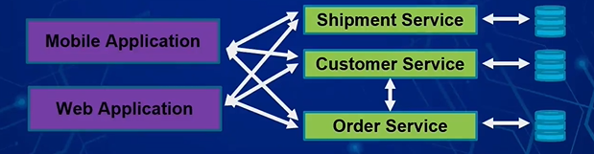

* API Led Connectivity is an integration approach which is a combination of Microservice+ SOA integration to meet today’s connectivity needs.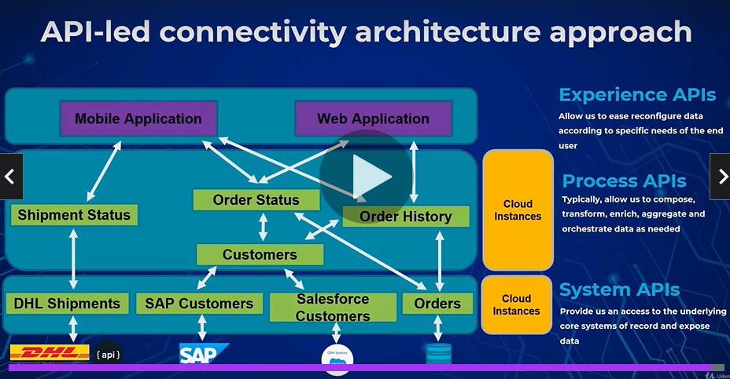
* Advantage of Mulesoft:-

Api’s are asset

Reusability of api’s

Faster development of API using exchange

Improved Governance or Management thru Anypoint Platform

Cloud Enablement

* Installations:-

1)JDK 8-Download n unzip the file.copy the filepath till \bin path n set the value in Environment variables for PATH variable.To check jdk installation in cmd type java -version n check with echo %path% to get all values of path variables

2)Maven- Download n unzip the file.copy the filepath till \bin path n set the value in Environment variables for PATH variable.To check maven installation in cmd type mvn -version n check path variables value in CMD with echo %path% to get all values of path variables

3)Git-Download n install GIT.open Git bash in the folder u want to initialize git.follow below cmds

Pwd(shows present working directory)

cd folder_name/(If you are in different file location other than folder u want to initialize git )

Git init(Initializes git folder)

Git status(Check status of git repo)

Notepad readme.md(to open notepad n create notepad file in git repo,add some comments in notepad file then save it)

Git status(Shows that you have readme.md file which is unstaged)

Git add .(to add all files in staging area of repo)

Git commit -m “created readme.md file”(commits the file in git repo with message)

If prompts for To add ur name n email in git

Git config –global user.name “Suryakant”

Git config –global user.email “ suryakantdubalgunde@gmail.com ”

To host the local repo in a server like github,gitlab,bigbucket,create an account let say github account n create new repo name xyz.in code tab you will see cmds for pushing the local git files to github server like below

Git remote add origin <https://github.com/username_of_github_account/xyz.git>

Git push -u origin master

After this you have to refresh the github page then you will see readme.md file in github server

4)MariaDb:Download n install while installing give password n same password can be used to login into mysql n Heidisql app.

5)Anypoint Studio:-Download n unzip it.

6)Postman:-Download n install.

* Flow

Flow is a scope that has all three components like source ,Process,Error Handling

Subflow:

Private Flow:-

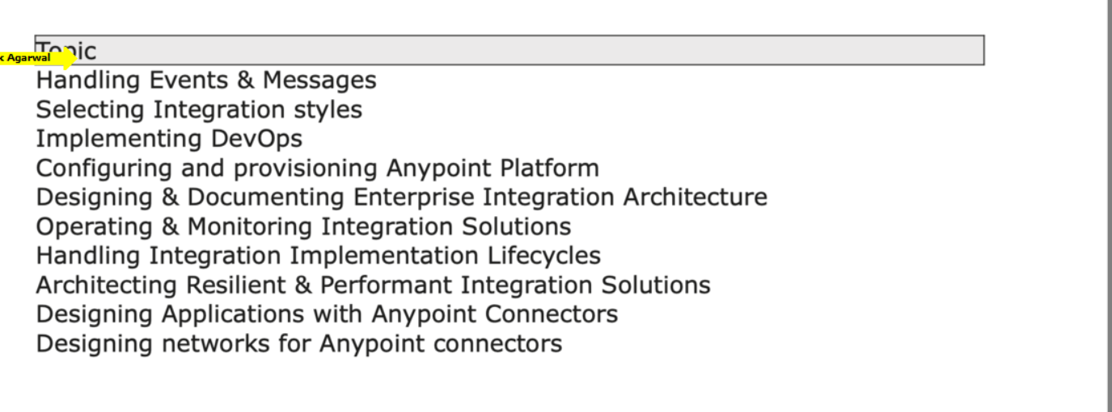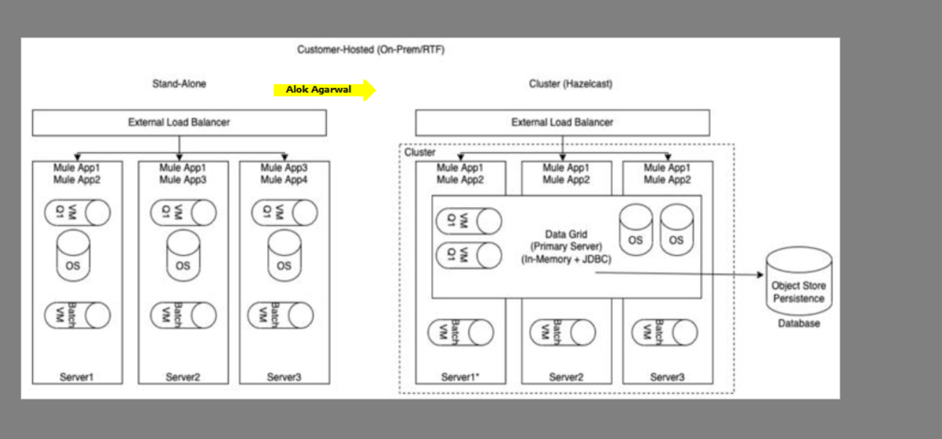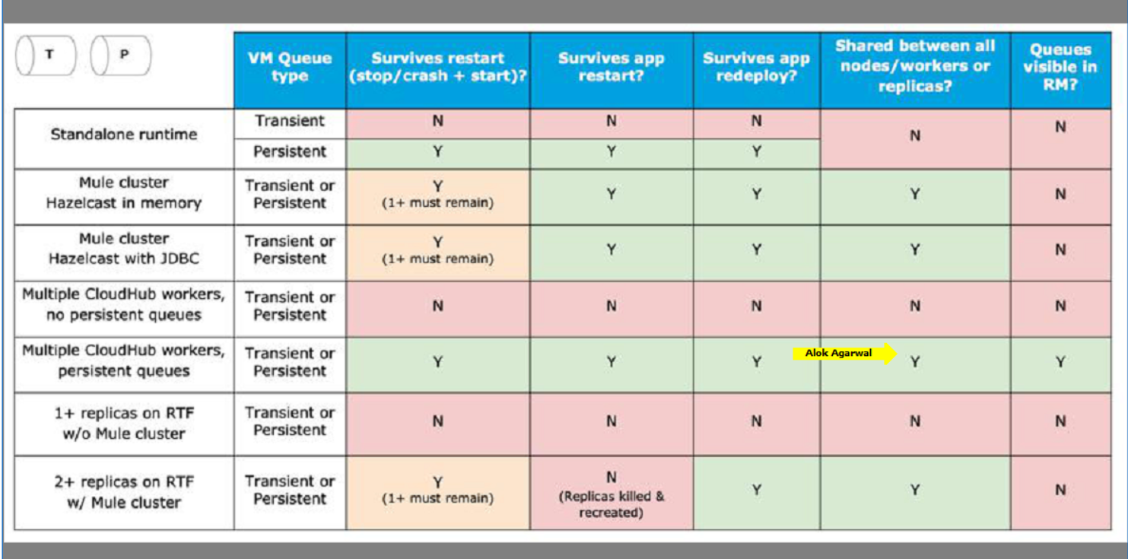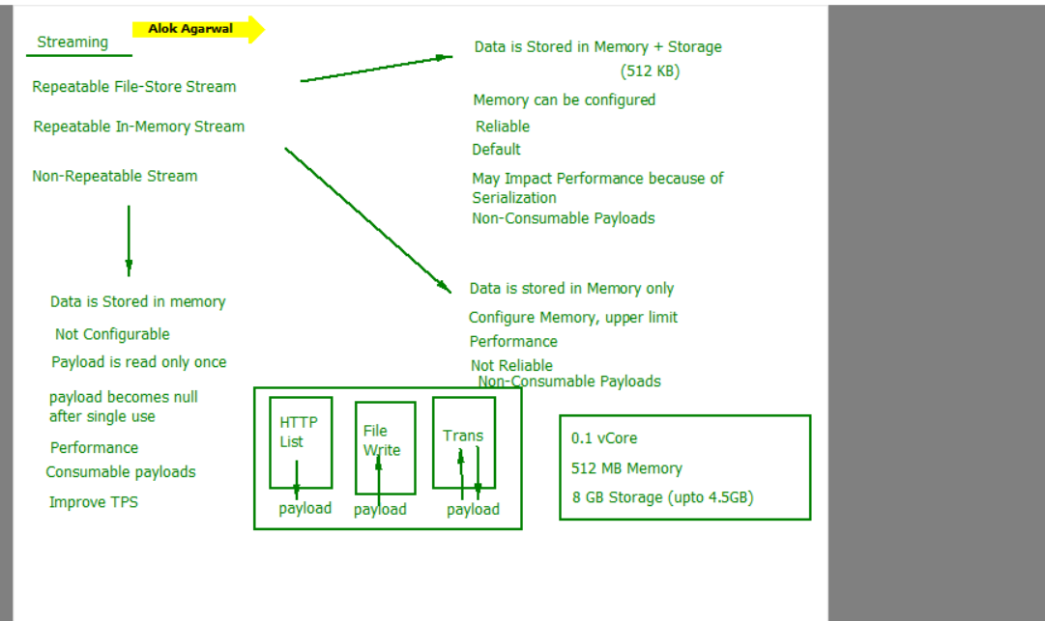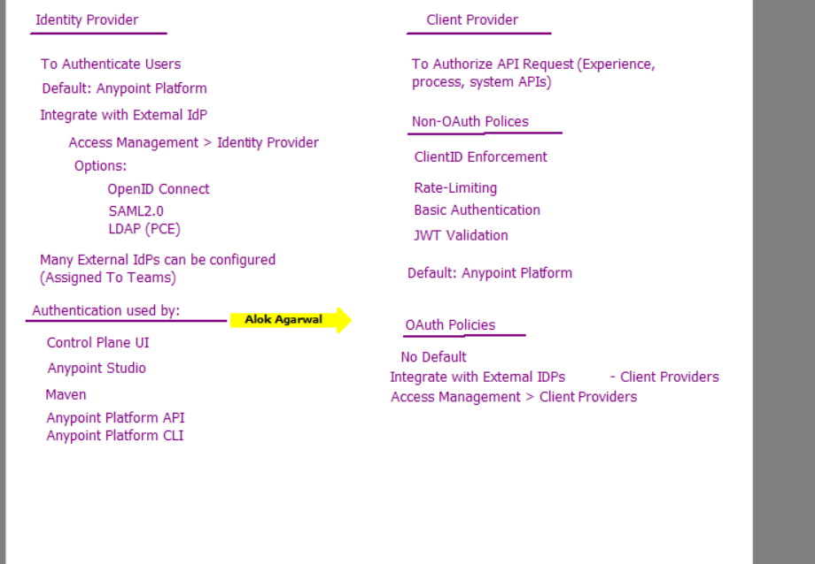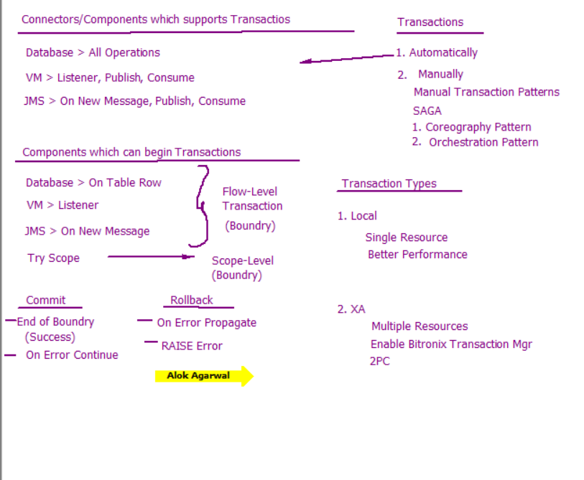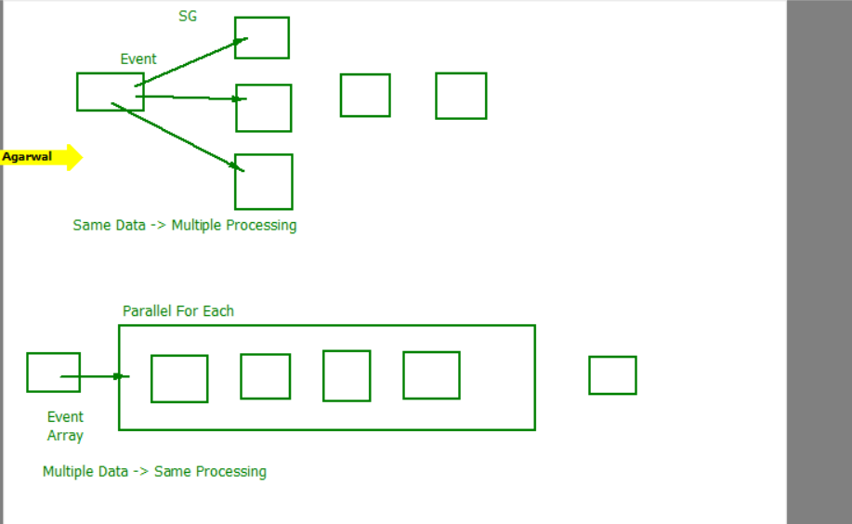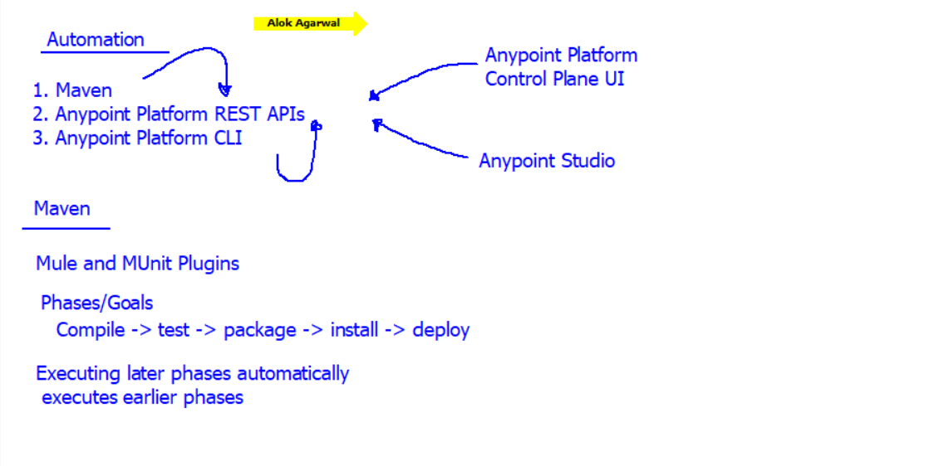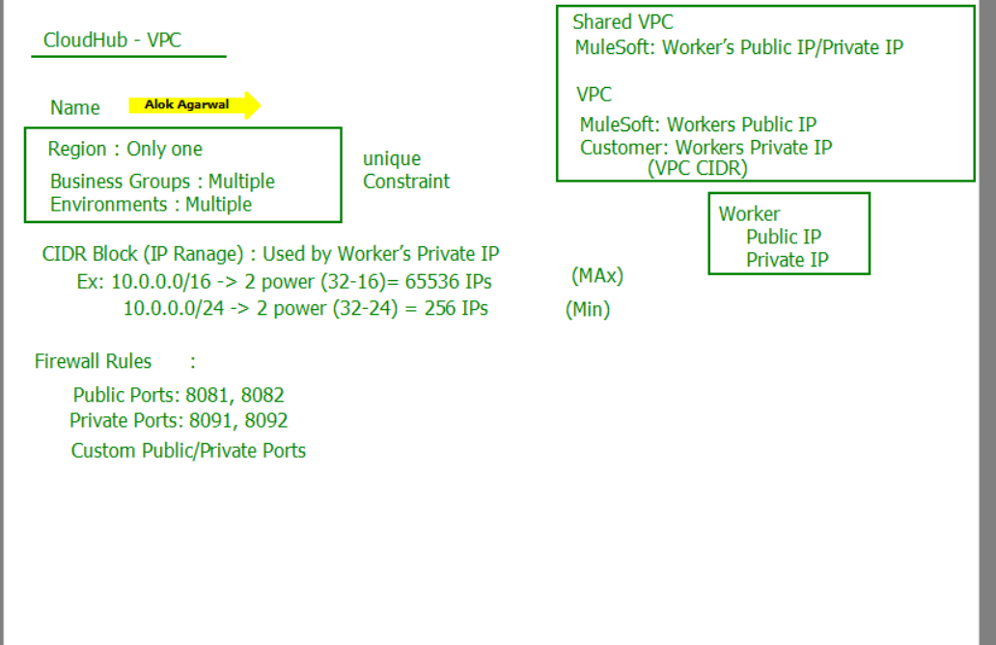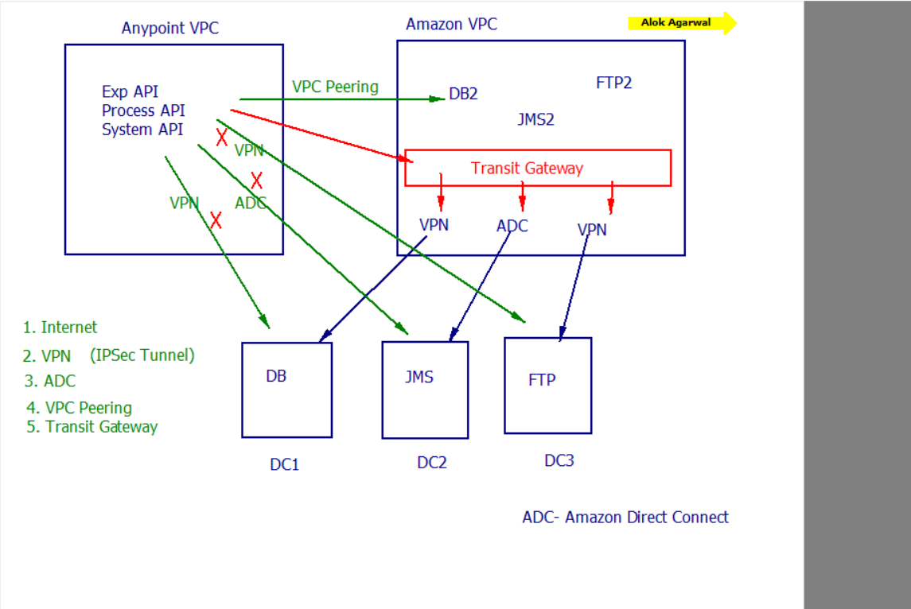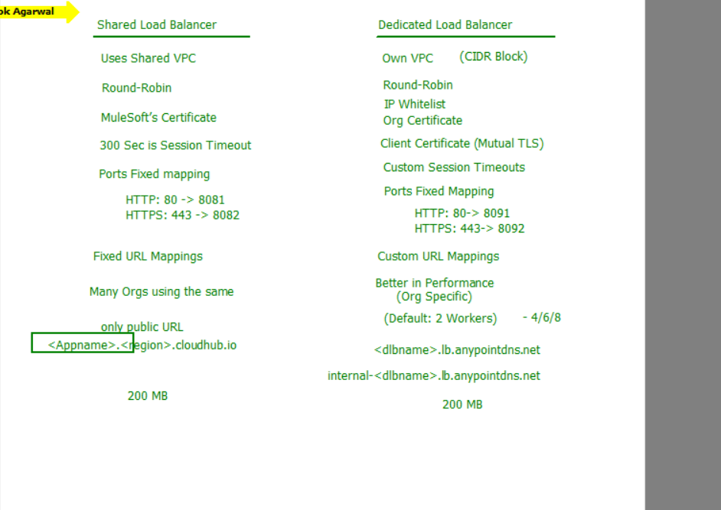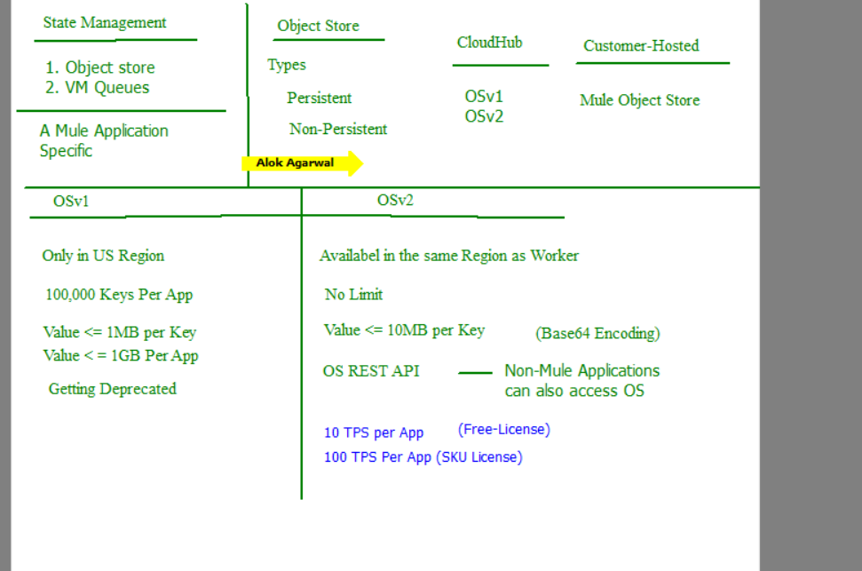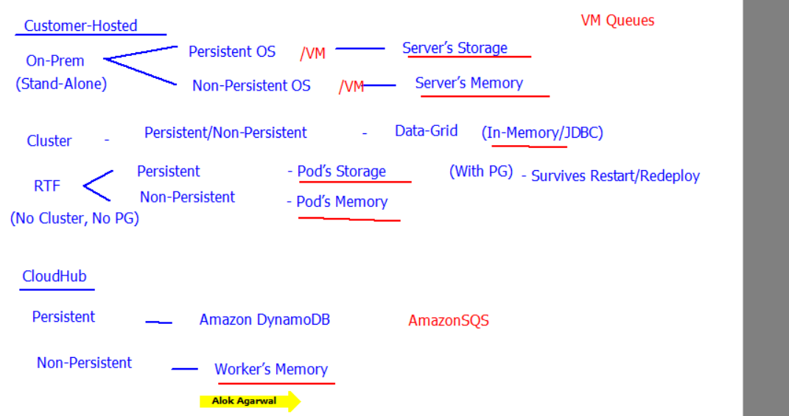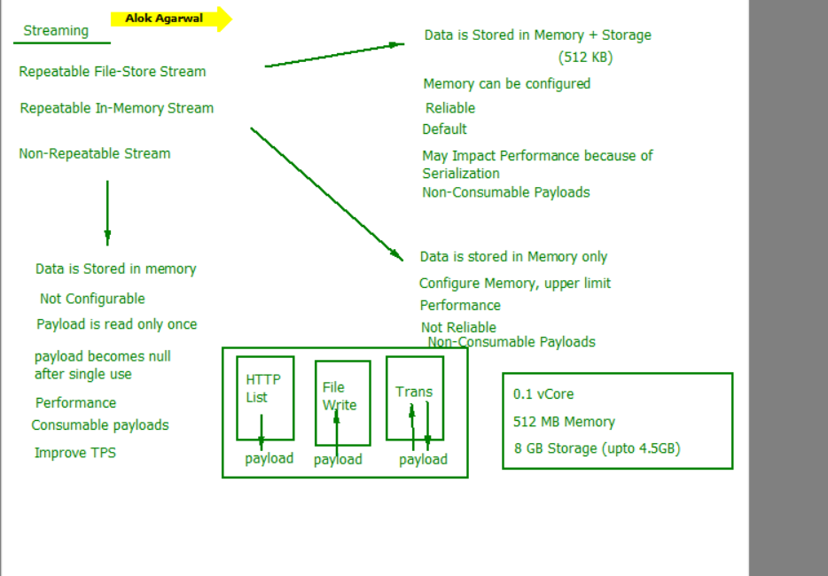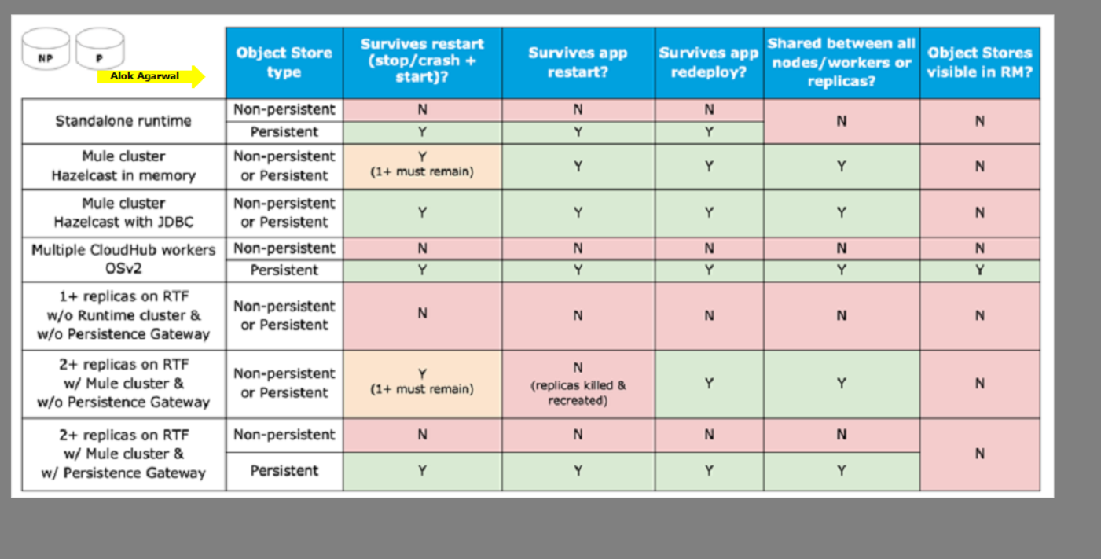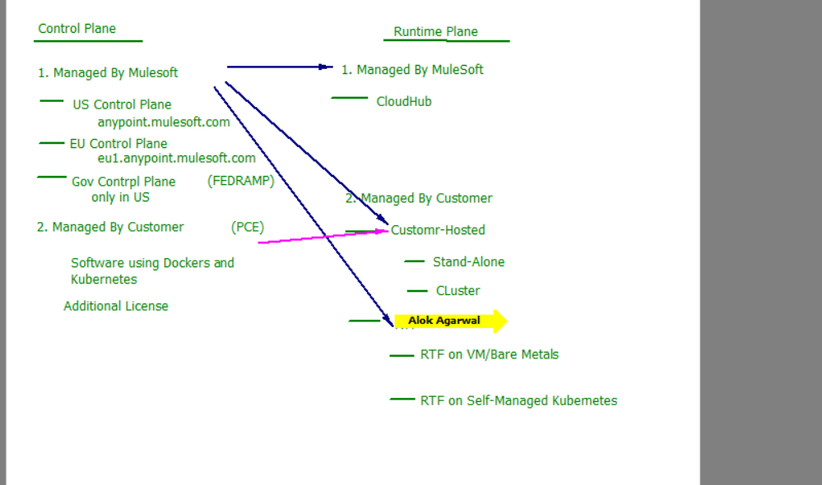

Why mulesoft:

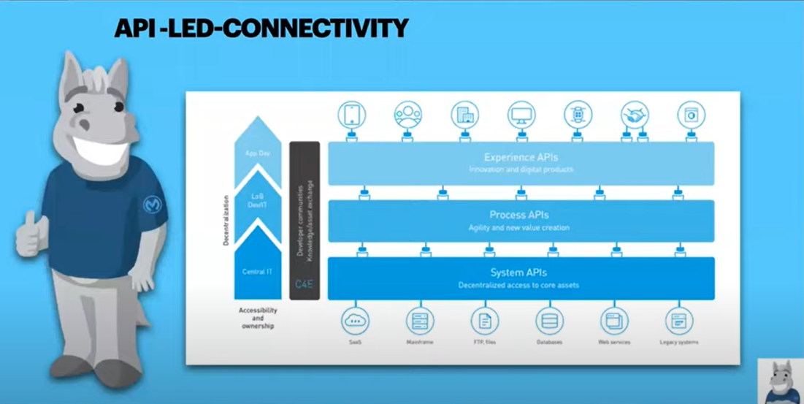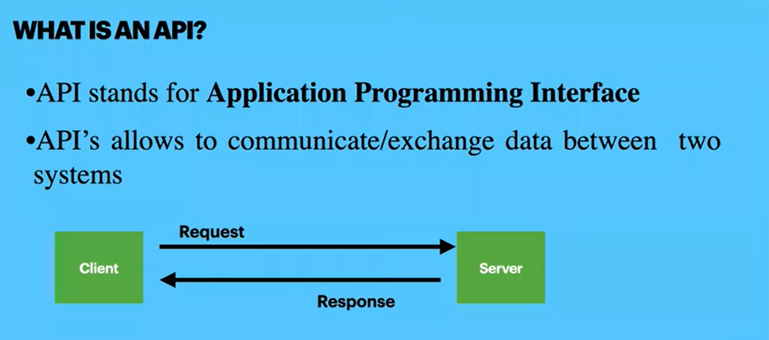

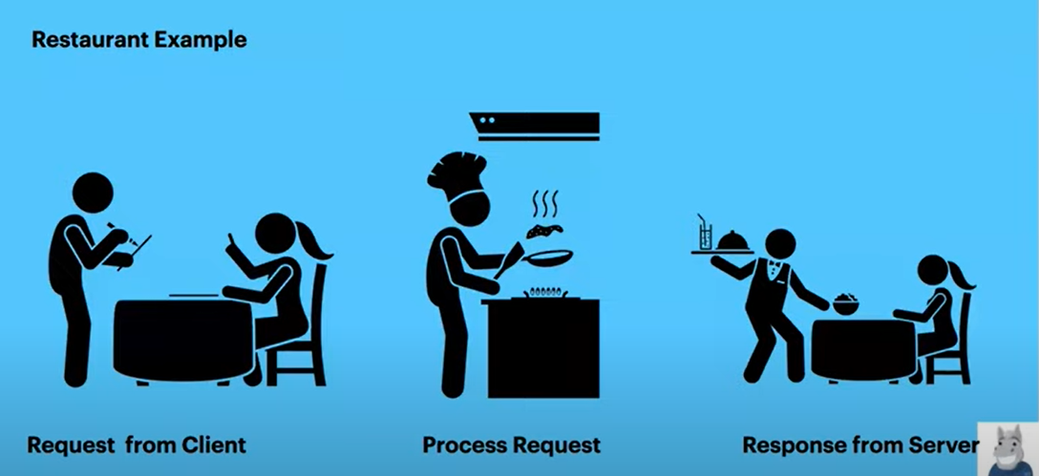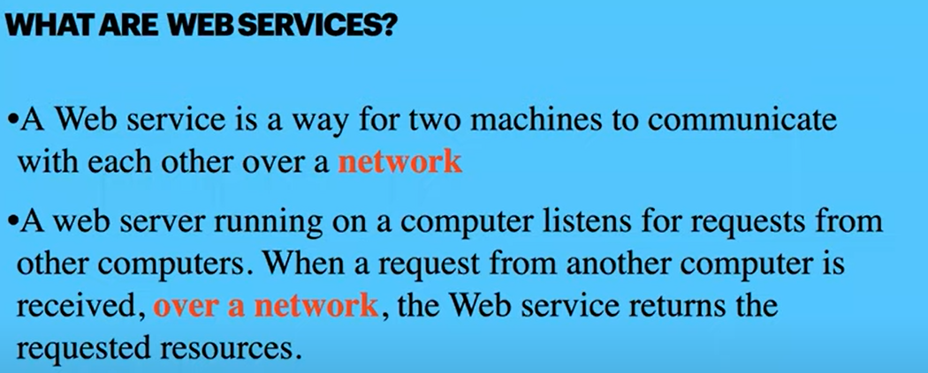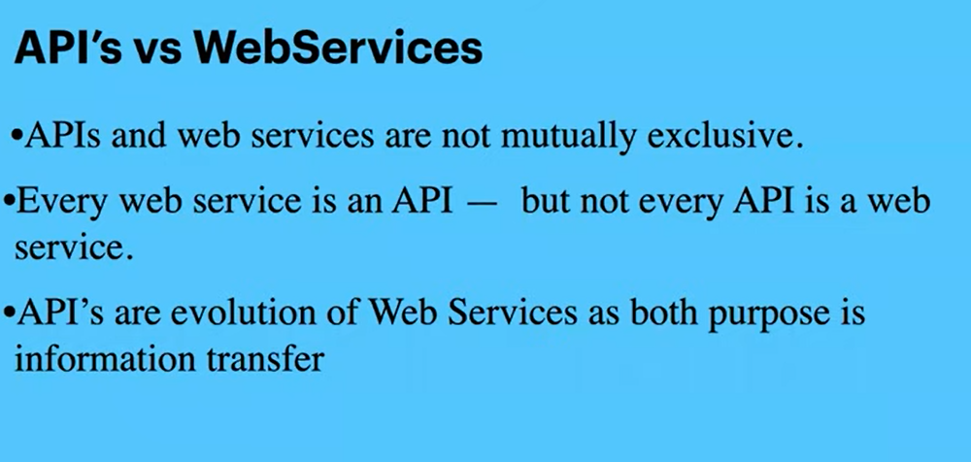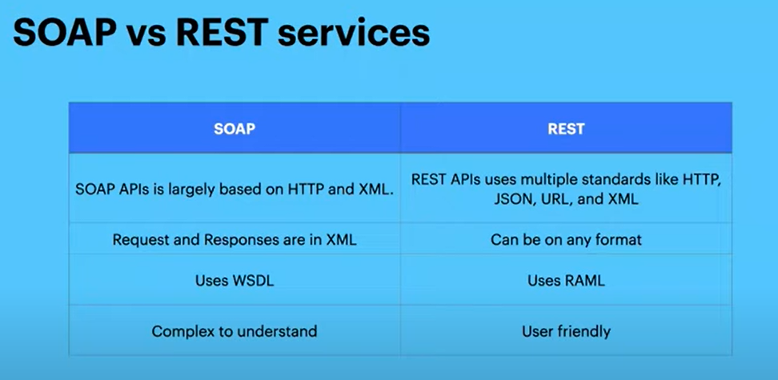

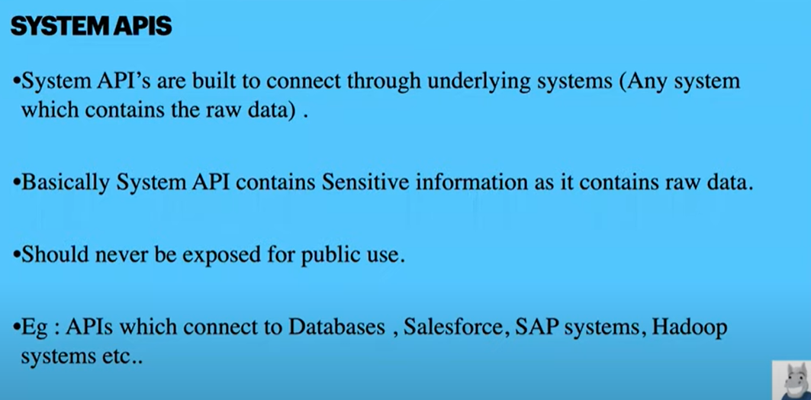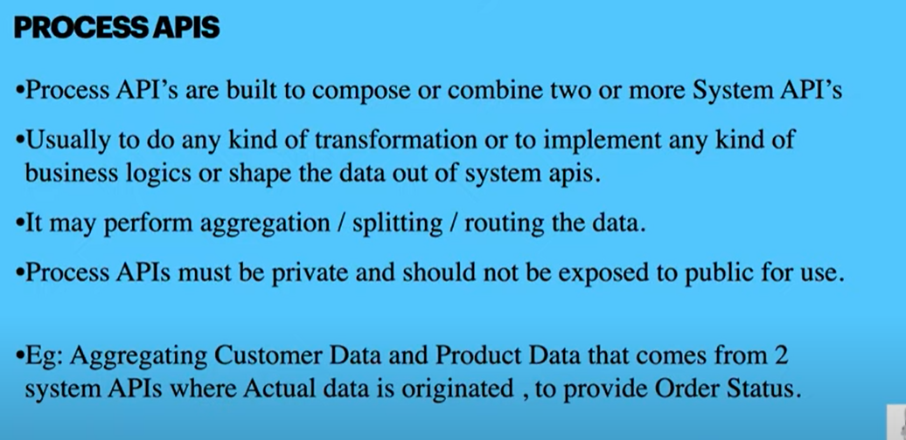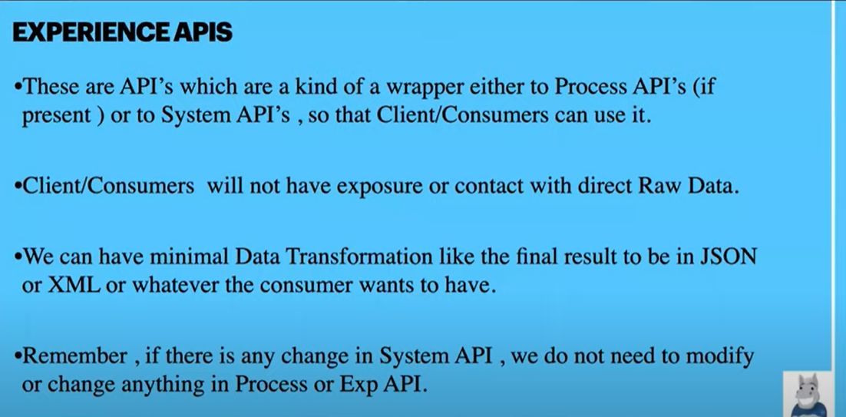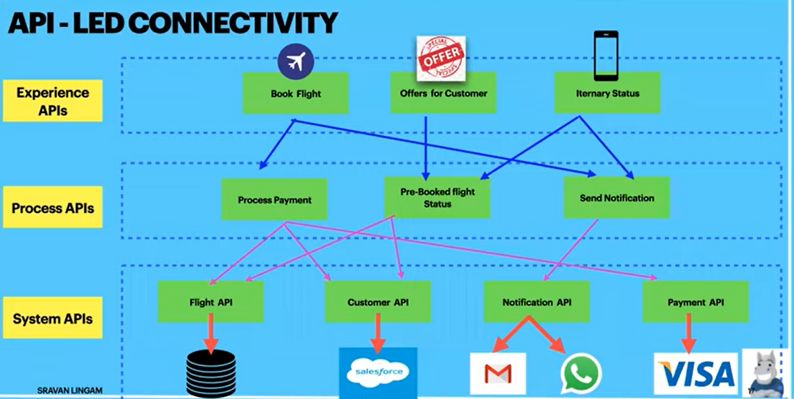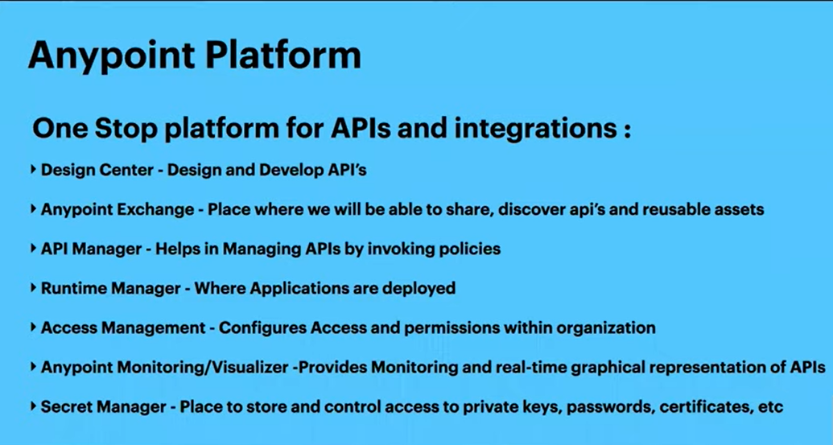

Designing APIs

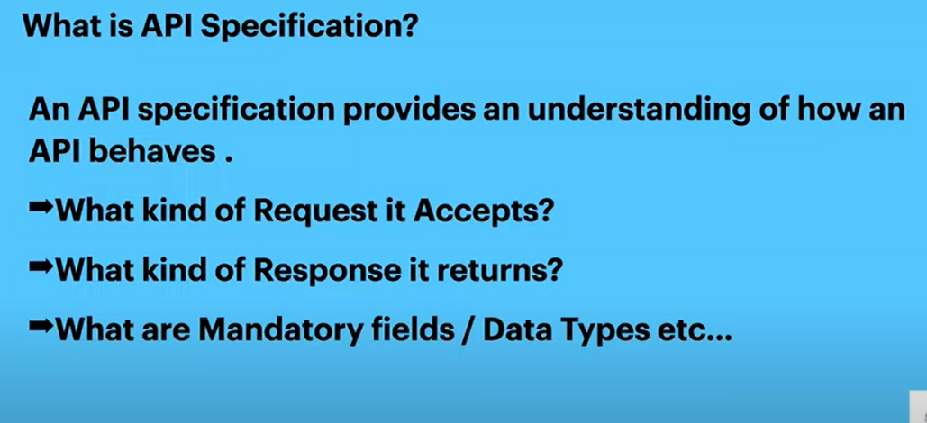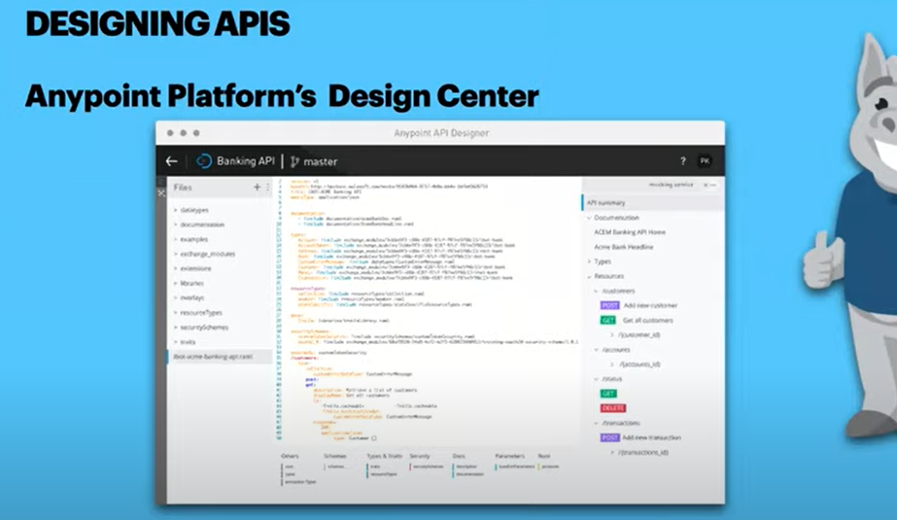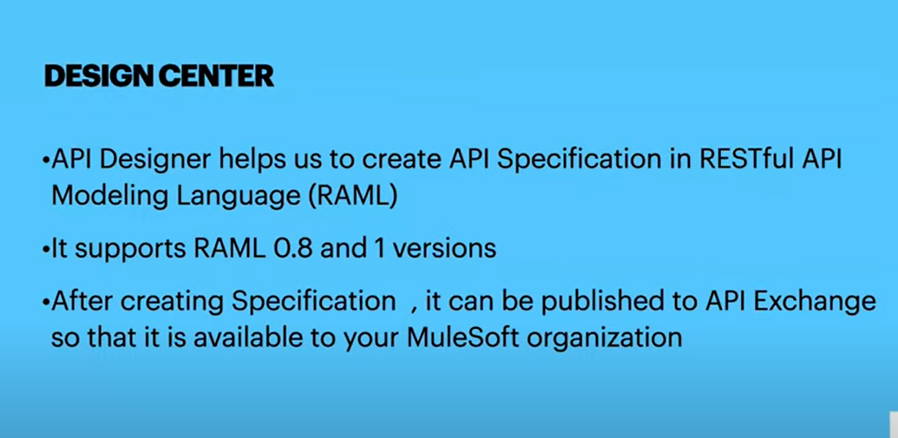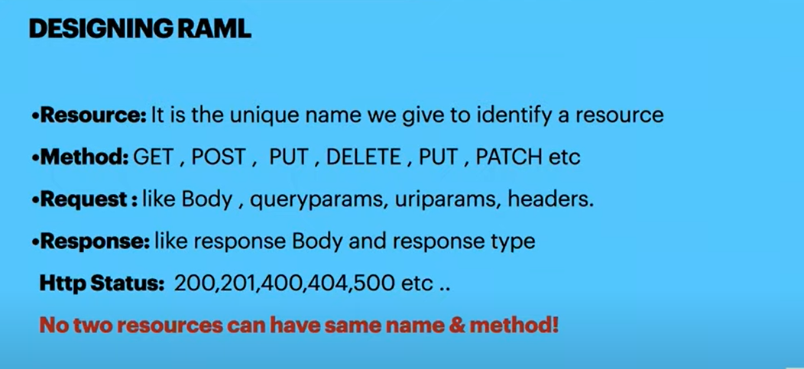

Note:-A RAML cannot have same resource name multiple times with diff. methods names like

Below:

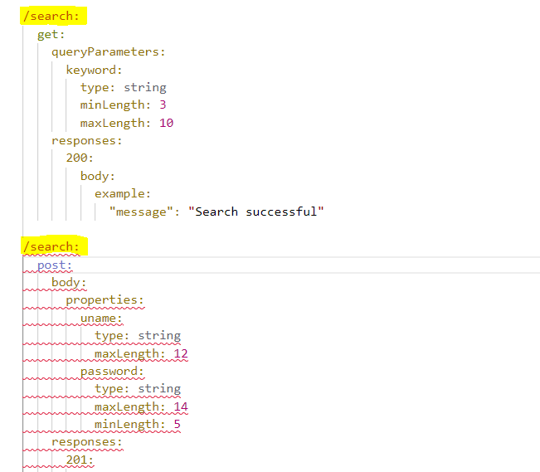

Note:A RAML cannot have same resource name multiple times with same method name also like below:

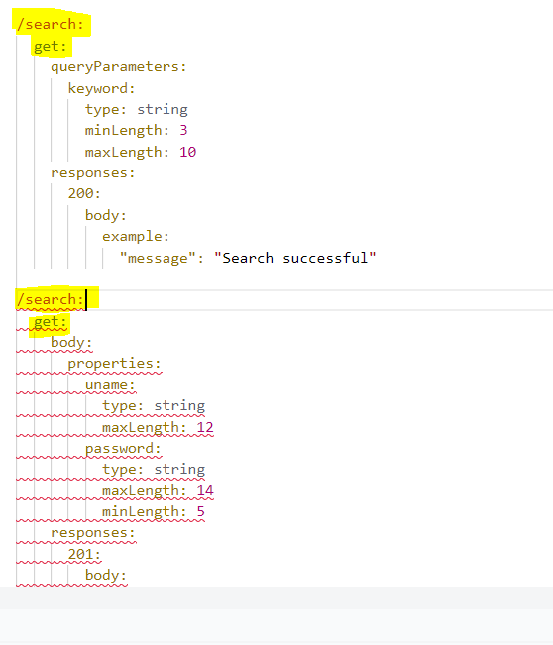

Note:A RAML cannot have one resource with Same method name declared multiple times.

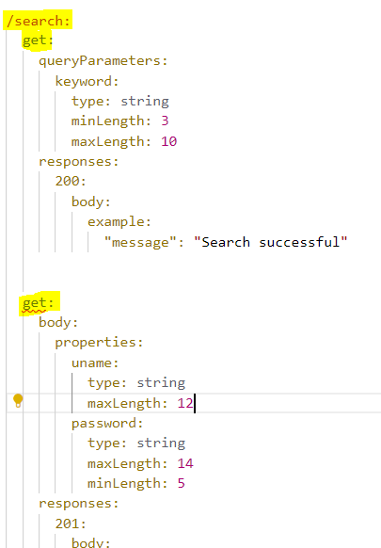

Correct RAML:

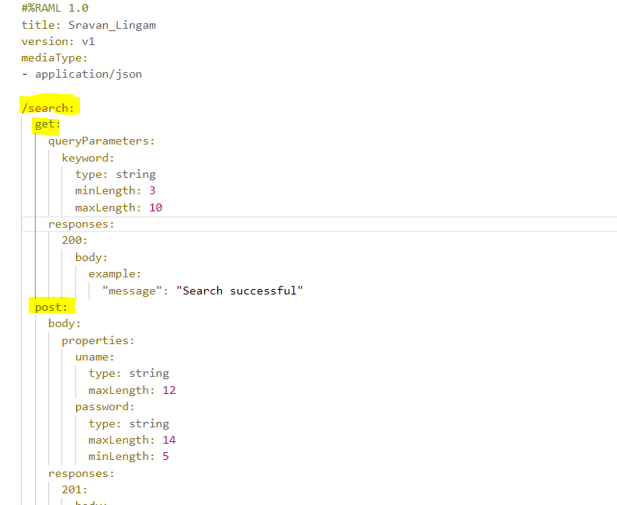

* What errors will get if we provide wrong resource name or wrong method or wrong request values

Wrong Resource Name: gives 404 not found error

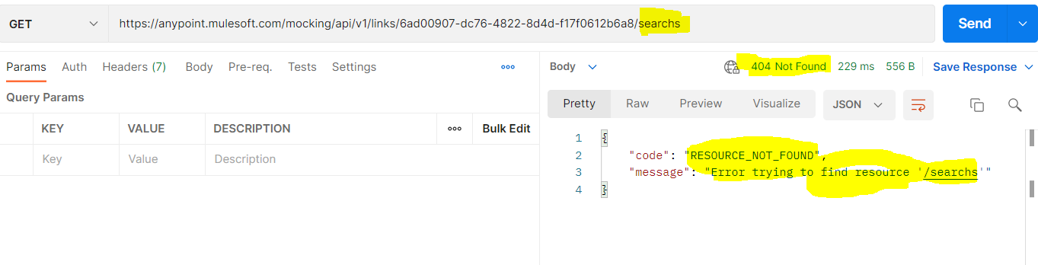

Wrong Method Name: gives 405 method not found error

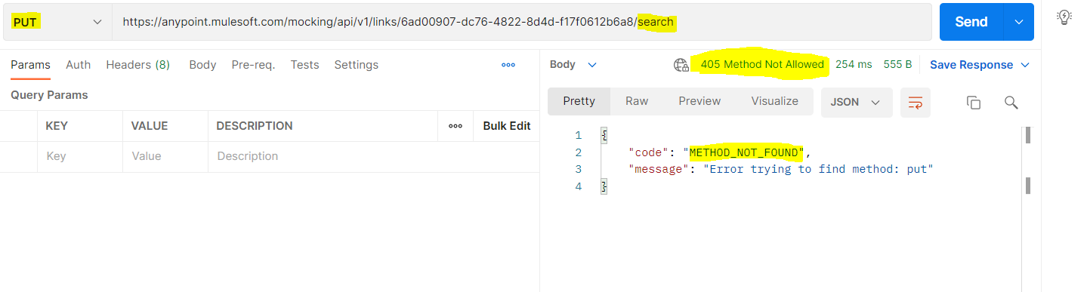

Wrong Request values: gives 400 Bad Request error 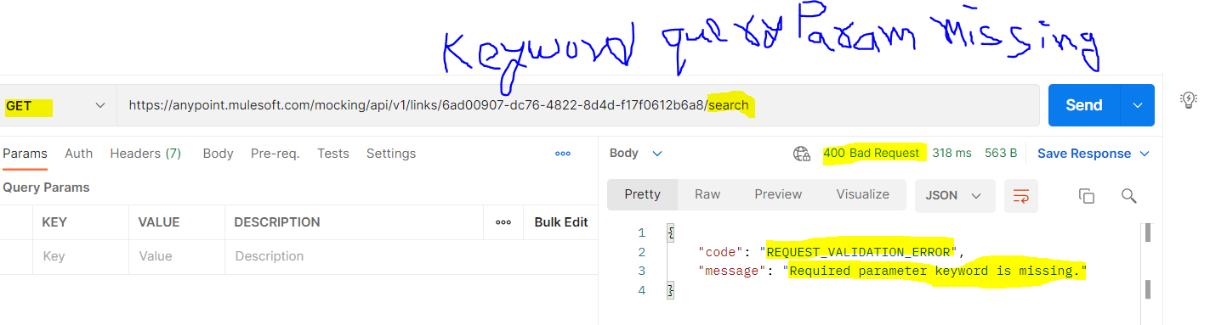

What if all three things are wrong,will provide 404 not found error as RAML validates inorder so first it will look for correct resource name,then method name n then request values.so if we have all the three things wronglly mentioned it will give resource name Not Found error with status 404. 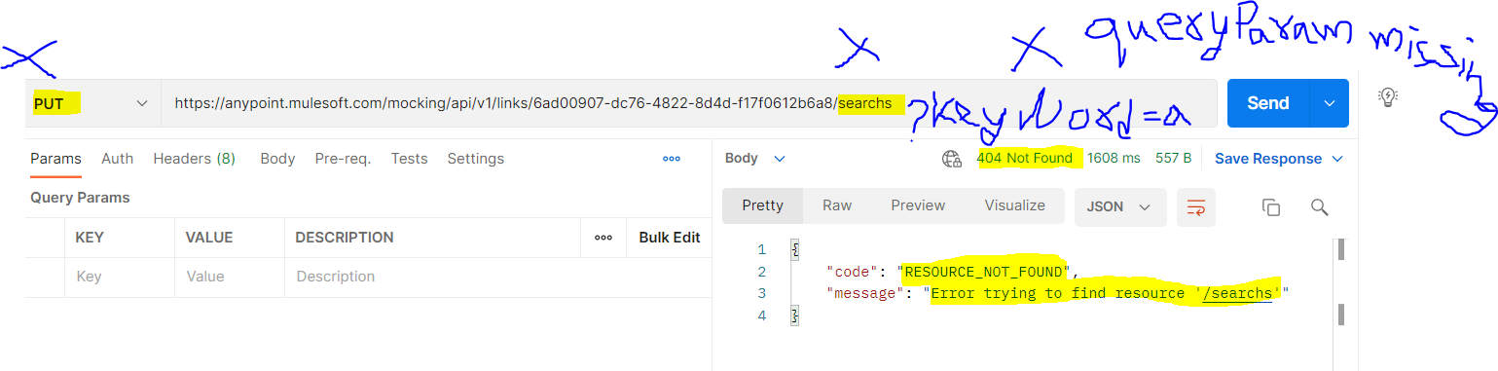

After applying concepts like traits,datatypes,resourcetypes,securityschemes,libraries the root raml file line of codes reduces

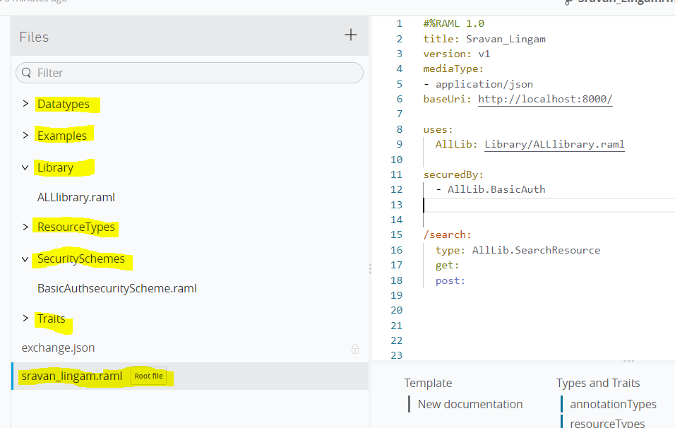

After publishing to Exchange with name change Sravan_Lingam_YoutubeCourse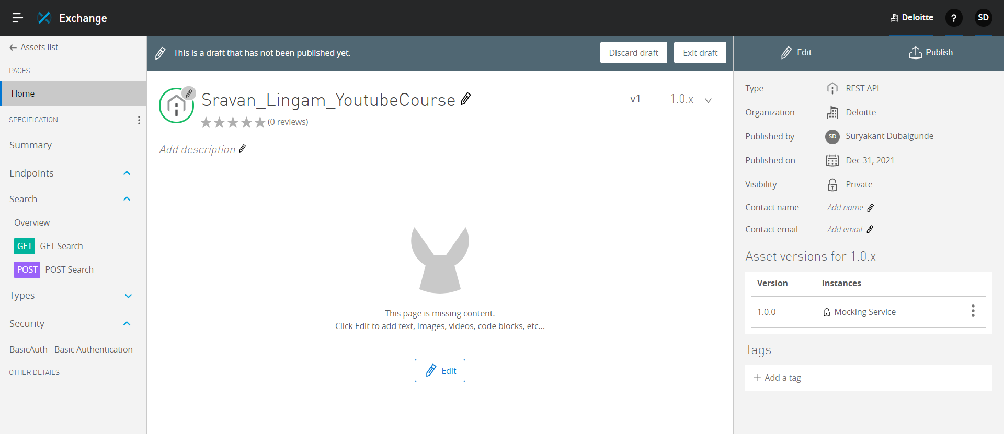

* **Developing API**

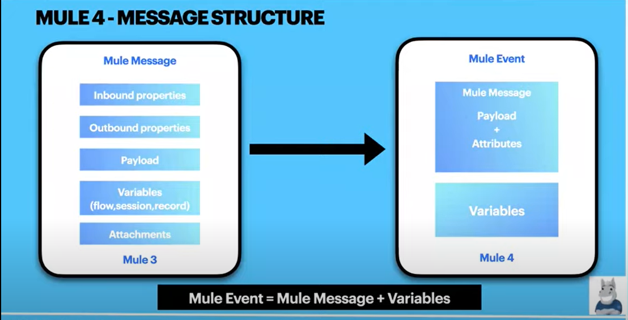

In Mule 4, Mule Message=Attributes+Payload

N Mule Event= Mule Message(Mule Message=Attributes+Payload )+ Variables

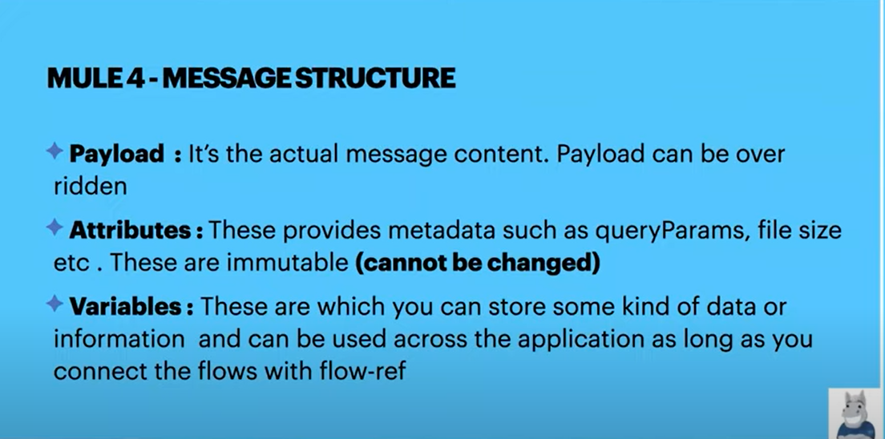

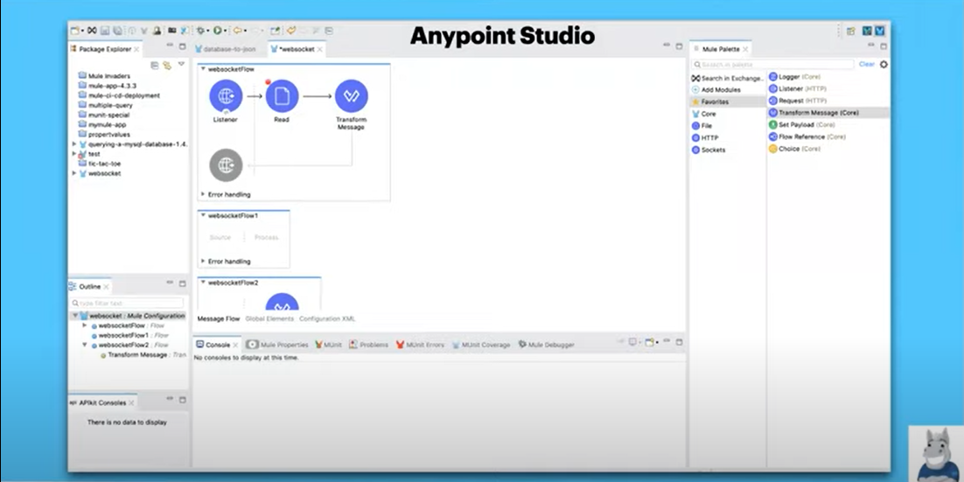 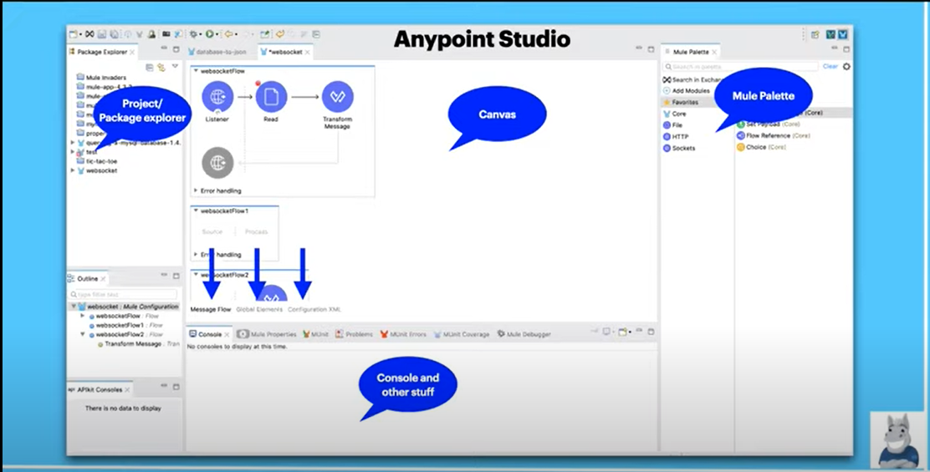 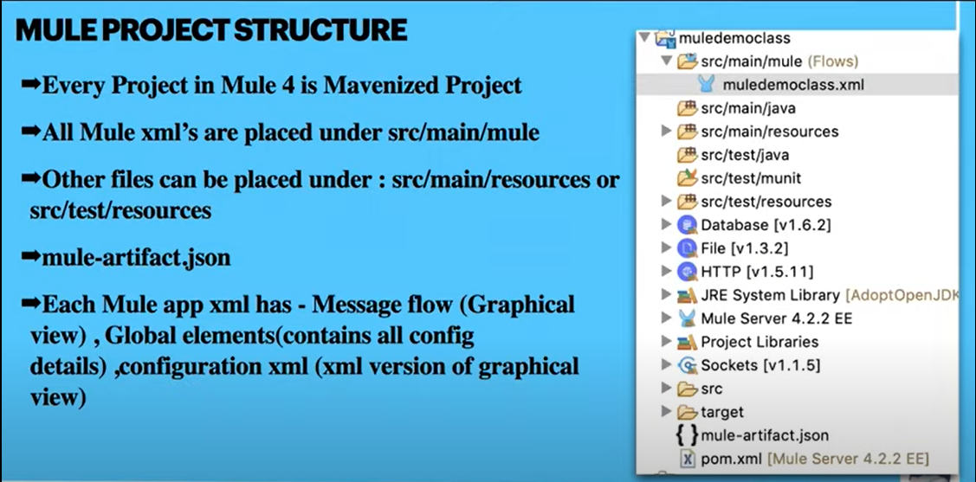 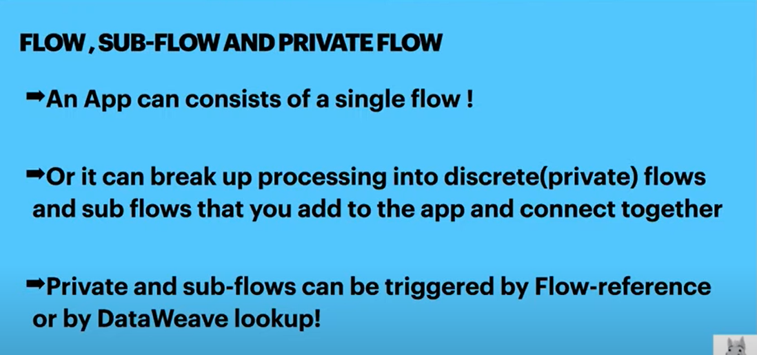 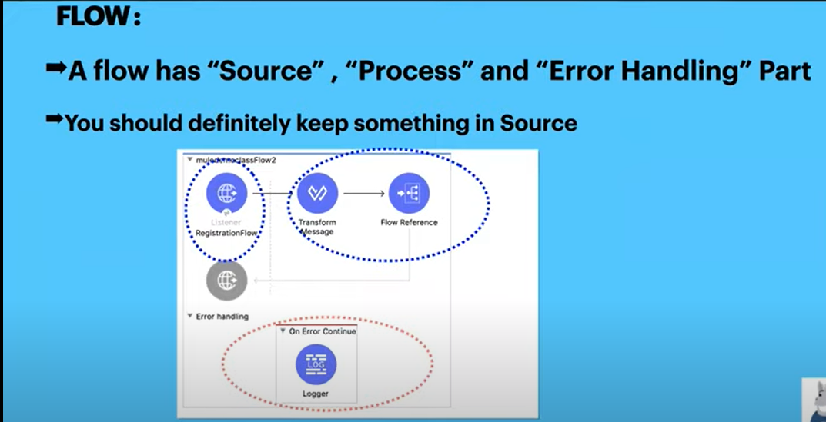 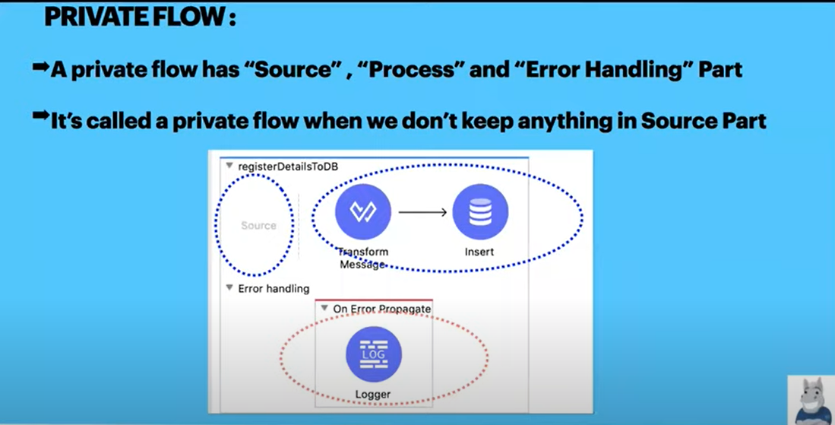 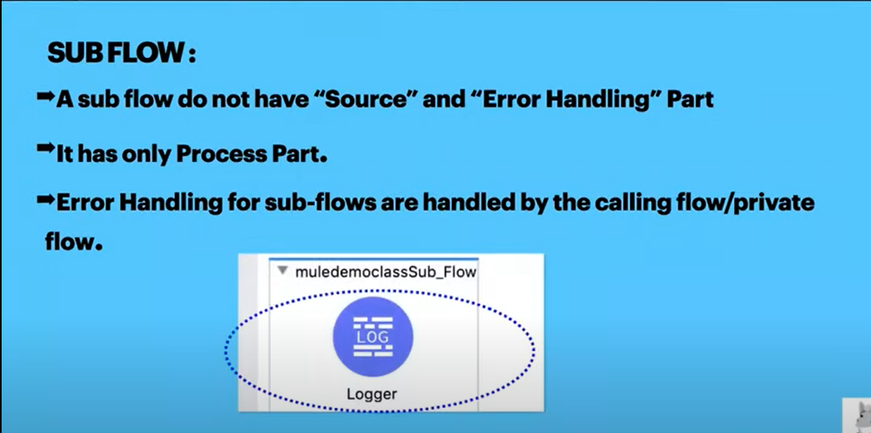 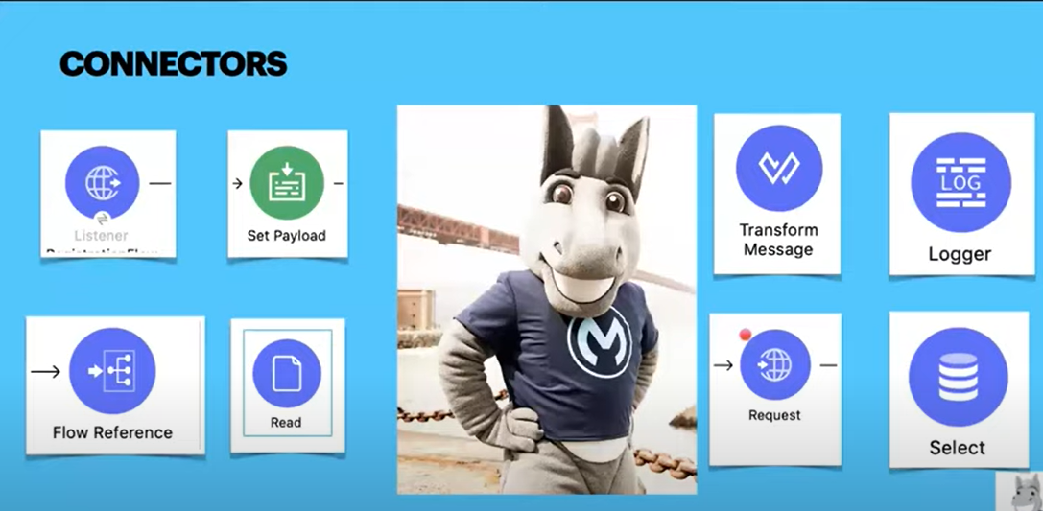 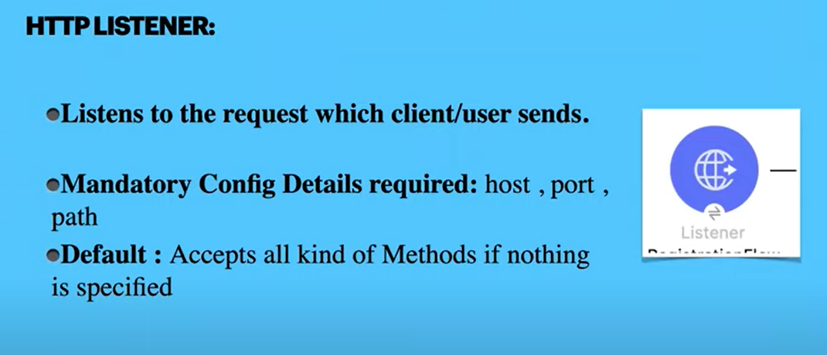 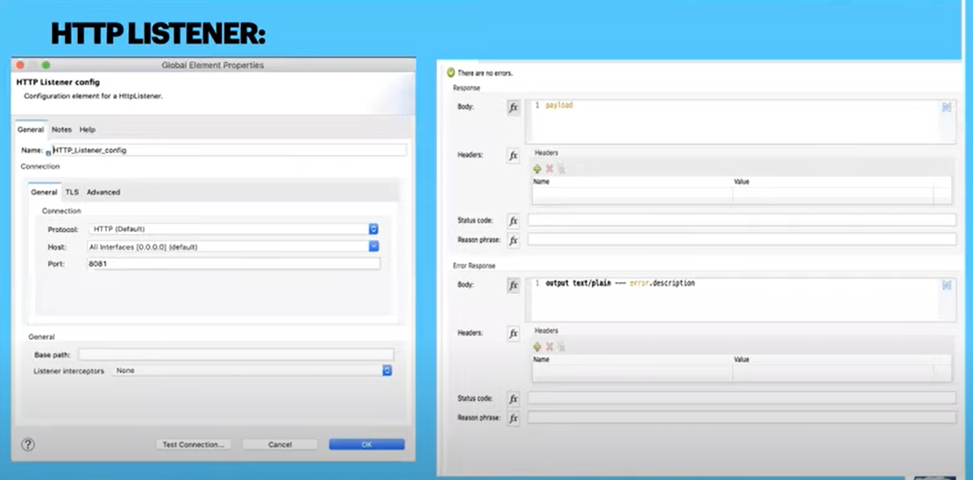 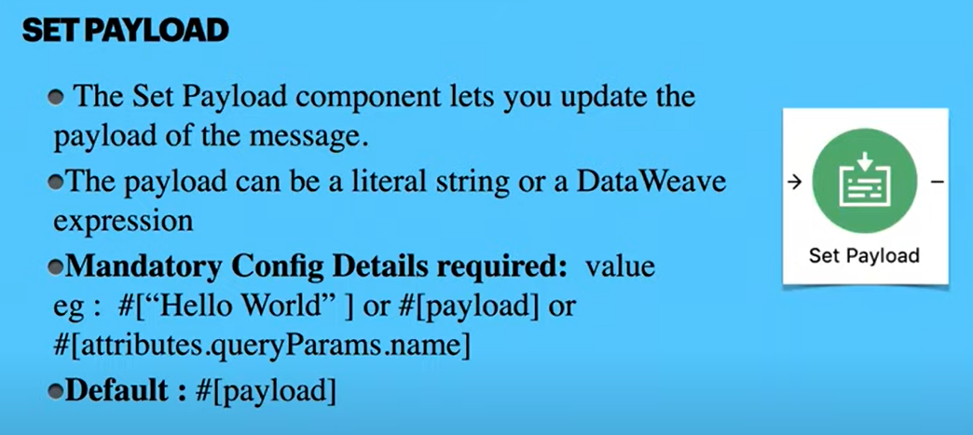 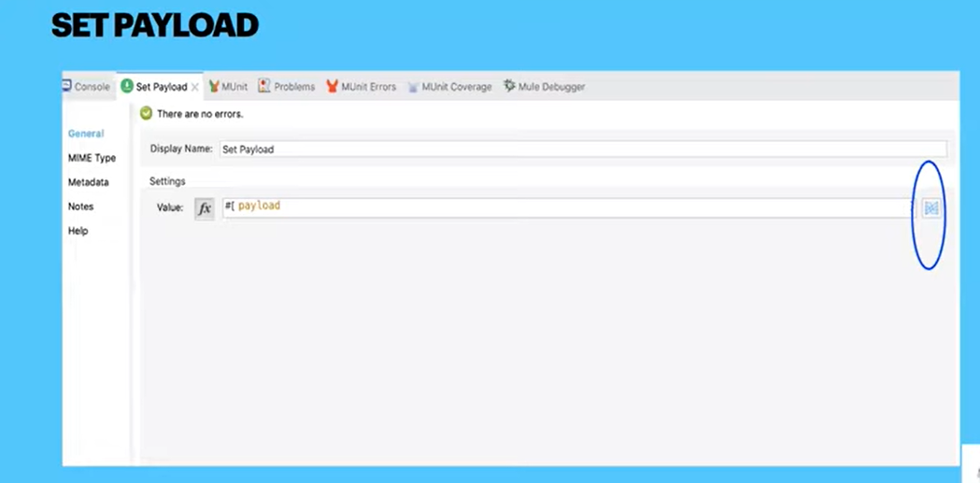

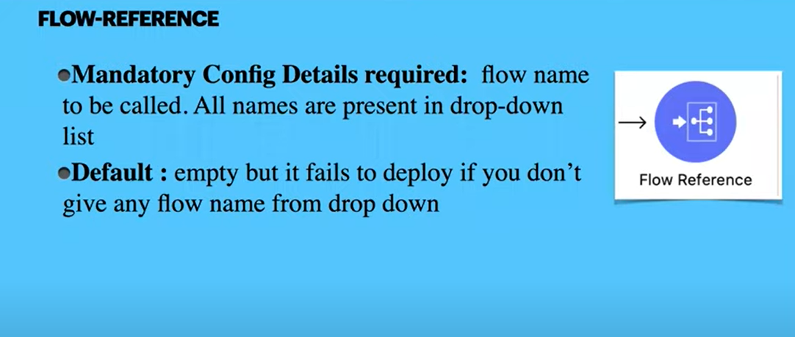 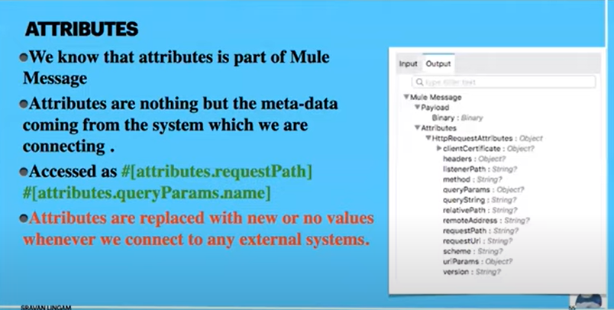 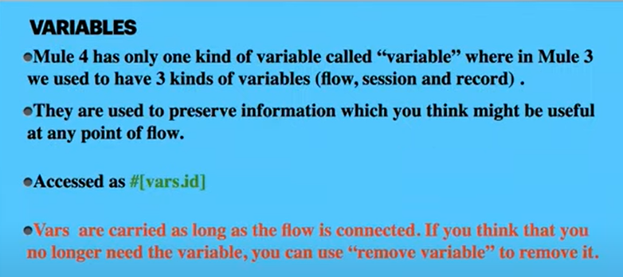 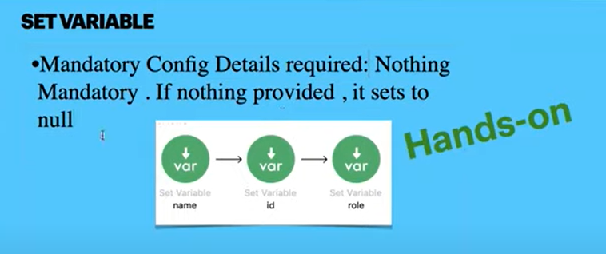  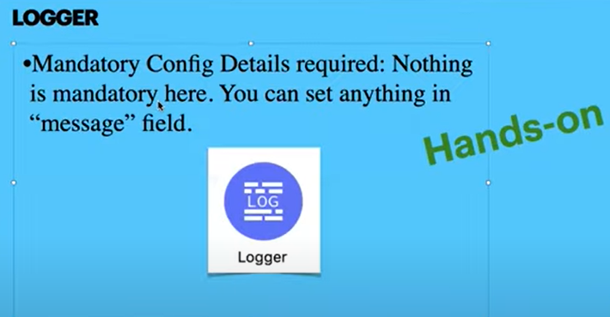

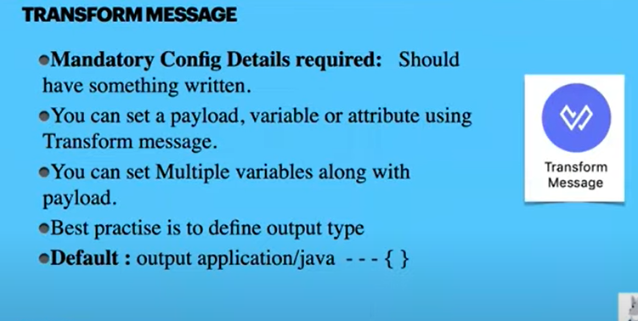 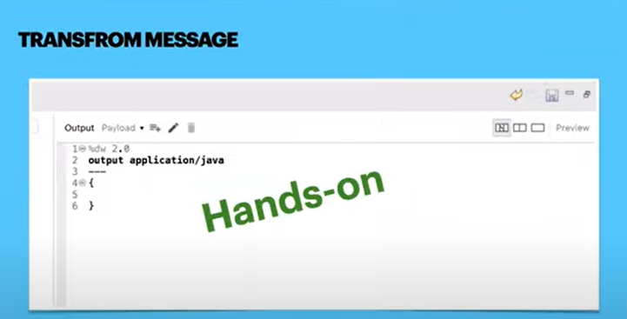

Note:

Instead of Set payload to set the payload or instead of Set Variable to set the variable we can use one connector called transform message which can be used for both purposes. Same as Set Payload is is used to set the payload n Same as Set Variable connector it is used to set the variables.

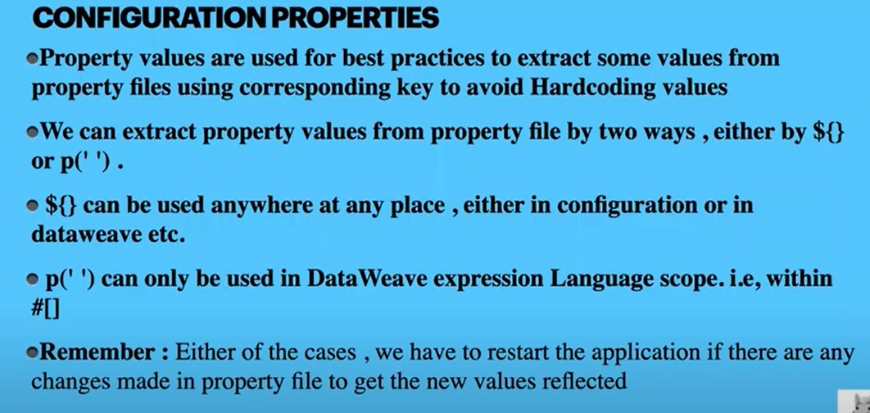

As we are already aware to access properties from properties file within #[] ,we use p(‘ ‘) also we can use ${} in #[] but with different way than original ${property_name}, How to use ${} in Mule expression language is like ‘${property_name}’

